**Blockchain**

A blockchain is a decentralized, distributed, and oftentimes public, digital ledger consisting of records called blocks that is used to record transactions across many computers so that any involved block cannot be altered retroactively, without the alteration of all subsequent blocks.

OR

A blockchain is a constantly growing ledger which keeps a permanent record of all the transactions that have taken place in a secure, chronological, and immutable way.

Let's breakdown the definition,

* **Ledger:** It is a file that is constantly growing.
* **Permanent:** It means once the transaction goes inside a blockchain, you can put up it permanently in the ledger.
* **Secure:** Blockchain placed information in a secure way. It uses very advanced cryptography to make sure that the information is locked inside the blockchain.
* **Chronological:** Chronological means every transaction happens after the previous one.
* **Immutable:** It means as you build all the transaction onto the blockchain, this ledger can never be changed.

A blockchain is a chain of blocks which contain information. Each block records all of the recent transactions, and once completed goes into the blockchain as a permanent database. Each time a block gets completed, a new block is generated.

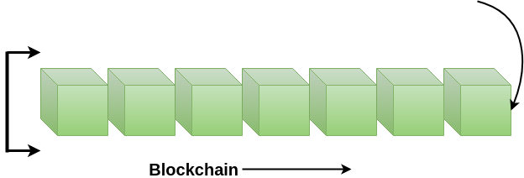

**Note:** A blockchain can be used for the secure transfer of money, property, contracts, etc. without requiring a third-party intermediary like bank or government. Blockchain is a software protocol, but it could not be run without the Internet (like SMTP used in email).

Who uses the blockchain?

Blockchain technology can be integrated into multiple areas. The primary use of blockchains is as a distributed ledger for cryptocurrencies. It shows great promise across a wide range of business applications like Banking, Finance, Government, Healthcare, Insurance, Media and Entertainment, Retail, etc.

Need of Blockchain

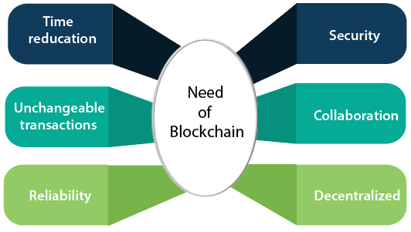

Blockchain technology has become popular because of the following.

* **Time reduction:** In the financial industry, blockchain can allow the quicker settlement of trades. It does not take a lengthy process for verification, settlement, and clearance. It is because of a single version of agreed-upon data available between all stakeholders.
* **Unchangeable transactions:** Blockchain register transactions in a chronological order which certifies the unalterability of all operations, means when a new block is added to the chain of ledgers, it cannot be removed or modified.
* **Reliability:** Blockchain certifies and verifies the identities of each interested parties. This removes double records, reducing rates and accelerates transactions.
* **Security:** Blockchain uses very advanced cryptography to make sure that the information is locked inside the blockchain. It uses Distributed Ledger Technology where each party holds a copy of the original chain, so the system remains operative, even the large number of other nodes fall.
* **Collaboration:** It allows each party to transact directly with each other without requiring a third-party intermediary.
* **Decentralized:** It is decentralized because there is no central authority supervising anything. There are standards rules on how every node exchanges the blockchain information. This method ensures that all transactions are validated, and all valid transactions are added one by one.

## What is decentralization?

In blockchain, decentralization refers to the transfer of control and decision-making from a centralized entity (individual, organization, or group thereof) to a distributed network. Decentralized networks strive to reduce the level of trust that participants must place in one another and deter their ability to exert authority or control over one another in ways that degrade the functionality of the network.

**Why it matters ??**

The nature of blockchain allows for trustless systems to be built on top of it. Users don’t rely on a centralized group of people, such as a bank, to make decisions and allow transactions to flow through. Because the system is decentralized, users know that transactions will never be denied for non-custodial reasons.

This decentralization enables use-cases that were previously impossible, such as parametric insurance, decentralized finance, and decentralized organizations (DAOs), among a few. This allows developers to build products that provide immediate value without having to go through a bureaucratic process of applications, approvals, and general red tape.

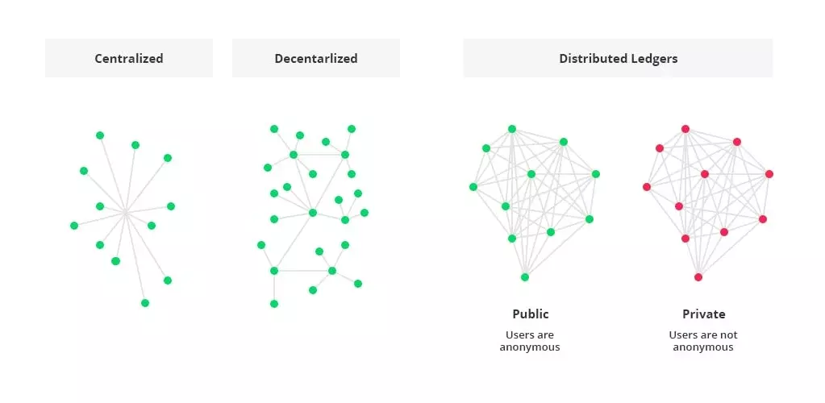**What is Blockchain Architecture?**

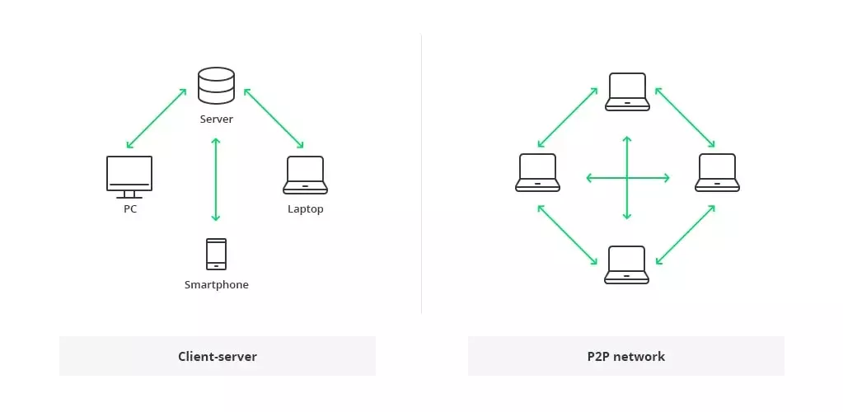

The traditional architecture of the World Wide Web uses a client-server network. In this case, the server keeps all the required information in one place so that it is easy to update, due to the server being a centralized database controlled by a number of administrators with permissions.

In the case of the distributed network of blockchain architecture, each participant within the network maintains, approves, and updates new entries. The system is controlled not only by separate individuals, but by everyone within the blockchain network. Each member ensures that all records and procedures are in order, which results in data validity and security. Thus, parties that do not necessarily trust each other are able to reach a common consensus.

To summarize things, the blockchain is a decentralized, distributed ledger (public or private) of different kinds of transactions arranged into a P2P network. This network consists of many computers, but in a way that the data cannot be altered without the consensus of the whole network (each separate computer).

* **Core Components of Blockchain Architecture: How Does It Work**

These are the core blockchain architecture components:

* Node - user or computer within the blockchain architecture (each has an independent copy of the whole blockchain ledger)
* Transaction - smallest building block of a blockchain system (records, information, etc.) that serves as the purpose of blockchain
* Block - a data structure used for keeping a set of transactions which is distributed to all nodes in the network
* Chain - a sequence of blocks in a specific order
* Miners - specific nodes which perform the block verification process before adding anything to the blockchain structure
* Consensus (consensus protocol) - a set of rules and arrangements to carry out blockchain operations

Any new record or transaction within the blockchain implies the building of a new block. Each record is then proven and digitally signed to ensure its genuineness. Before this block is added to the network, it should be verified by the majority of nodes in the system.

The following is a blockchain architecture diagram that shows how this actually works in the form of a digital wallet.

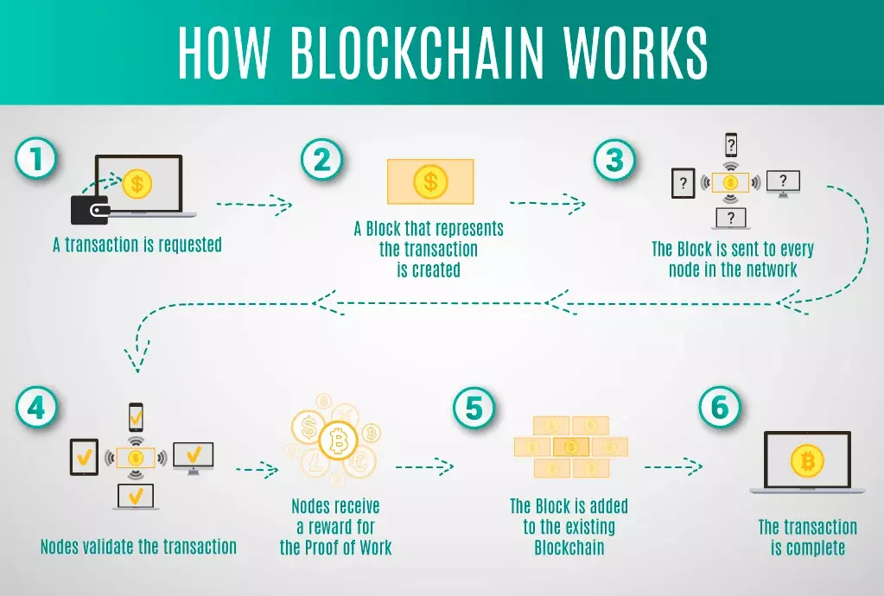

Let's have a closer look at what is a block in a blockchain. Each blockchain block consists of:

* certain data
* the hash of the block
* the hash from the previous block

The data stored inside each block depends on the type of blockchain. For instance, in the Bitcoin blockchain structure, the block maintains data about the receiver, sender, and the amount of coins.

A hash is like a fingerprint (long record consisting of some digits and letters). Each block hash is generated with the help of a cryptographic hash algorithm (SHA 256). Consequently, this helps to identify each block in a blockchain structure easily. The moment a block is created, it automatically attaches a hash, while any changes made in a block affect the change of a hash too. Simply stated, hashes help to detect any changes in blocks.

The final element within the block is the hash from a previous block. This creates a chain of blocks and is the main element behind blockchain architecture’s security. As an example, block 45 points to block 46. The very first block in a chain is a bit special - all confirmed and validated blocks are derived from the genesis block.

Any corrupt attempts provoke the blocks to change. All the following blocks then carry incorrect information and render the whole blockchain system invalid.

On the other hand, in theory, it could be possible to adjust all the blocks with the help of strong computer processors. However, there is a solution that eliminates this possibility called proof-of-work. This allows a user to slow down the process of creation of new blocks. In Bitcoin blockchain architecture, it takes around 10 minutes to determine the necessary proof-of-work and add a new block to the chain. This work is done by miners - special nodes within the Bitcoin blockchain structure. Miners get to keep the transaction fees from the block that they verified as a reward.

Each new user (node) joining the peer-to-peer network of blockchain receives a full copy of the system. Once a new block is created, it is sent to each node within the blockchain system. Then, each node verifies the block and checks whether the information stated there is correct. If everything is alright, the block is added to the local blockchain in each node.

All the nodes inside a blockchain architecture create a consensus protocol. A consensus system is a set of network rules, and if everyone abides by them, they become self-enforced inside the blockchain.

For example, the Bitcoin blockchain has a consensus rule stating that a transaction amount must be cut in half after every 200,000 blocks. This means that if a block produces a verification reward of 10 BTC, this value must be halved after every 200,000 blocks.

As well, there can only be 4 million BTC left to be mined, since there is a maximum of 21 million BTC laid down in the Bitcoin blockchain system by the protocol. Once the miners unlock this many, the supply of Bitcoins ends unless the protocol is changed.

To recap, this makes blockchain technology immutable and cryptographically secure by eliminating any third-parties. It is impossible to tamper with the blockchain system; as it would be necessary to tamper with all of its blocks, recalculate the proof-of-work for each block, and also control more than 50% of all the nodes in a peer-to-peer network.

**Centralized vs. Decentralized Networks**

To better understand blockchain technology, let's now review a real-world situation of paying for a cup of coffee with a credit card. In this example of a centralized network, there are several intermediaries to facilitate the transaction:

* The customer's bank
* The credit card's bank
* A credit card agency
* An exchange
* The merchant's bank
* The merchant

In a decentralized system, the customer and merchant could transact directly with one another. In this case, functions of the intermediaries are shifted to the periphery—to the peer-to-peer participants in the blockchain infrastructure.

These peers are not necessarily known to each other, although they are able to establish trust by having a process that can validate, verify, and confirm transactions.

Transactions are also recorded in a distributed ledger of blocks, which creates a chain of blocks that cannot be tampered with.

A blockchain also has a consensus protocol that defines an agreement of how a block will be added to the chain.

Through these mechanisms of validation, verification, consensus, and immutable record-keeping lead to trust and security between peers of a blockchain.

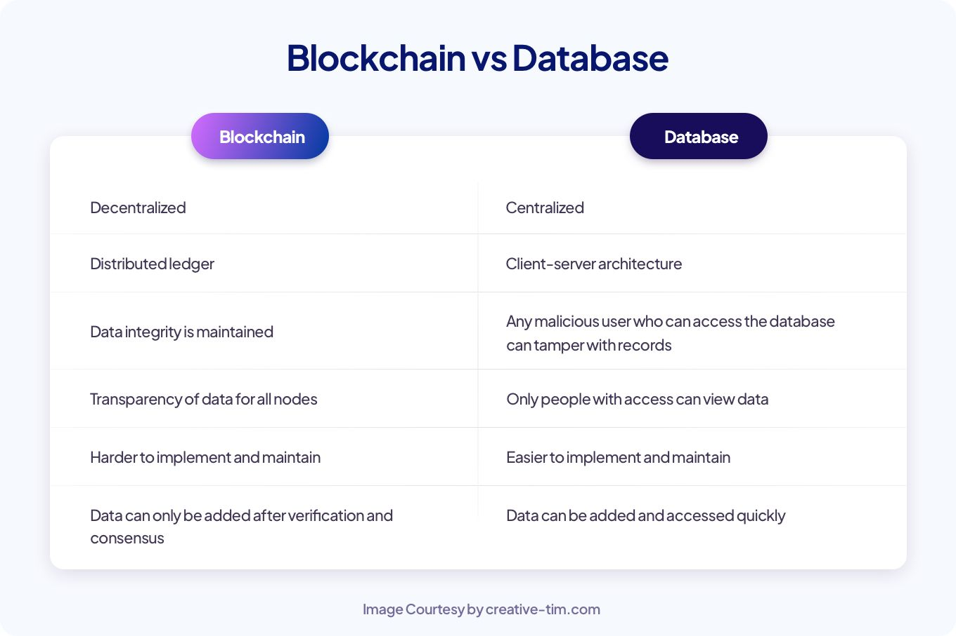

**Specifically, a few real-world examples of blockchains application in these industries include:**

* **Digital media transfer:** for example the sale of art and collectibles with non-fungible tokens (NFTs)
* **Remote services delivery:** for example in the travel and tourism industry
* **Decentralized business logic:** for example moving computing to data sources
* **Distributed intelligence:** for example in education credentialing
* **Distributed resources:**for example, in power generation and distribution
* **Crowdfunding:**for example in startup financing
* **Crowd operations:** for example, in electronic voting
* **Identity management:** for example, having a single ID

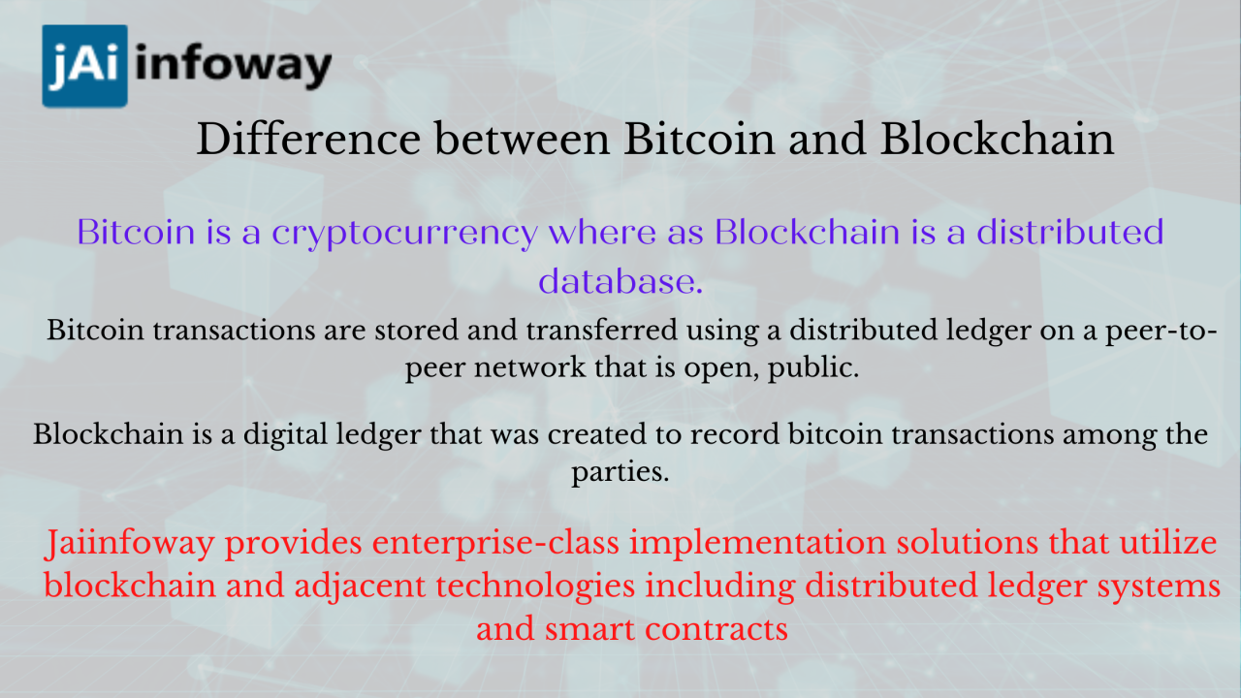

**Basic Blockchain Operations**

**Operations in a decentralized networks are the responsibility of the peer participants and their respective computational nodes.**

In particular, these operations include:

* Gathering the transactions for a block
* Broadcasting valid transactions and blocks
* Reaching consensus on the next block to be created
* Chaining the blocks together to form an immutable record

**Storage**

Unlike a centralized server operated by a single company or organization, decentralized storage systems consist of a peer-to-peer network of user-operators who hold a portion of the overall data, creating a resilient file storage sharing system.

**What is blockchain storage?**

Blockchain storage is a way of saving data in a decentralized network, which utilizes the unused hard disk space of users across the world to store files. The decentralized infrastructure is an alternative to centralized cloud storage and can solve many problems found in a centralized system.

**How blockchain storage works**

Blockchain relies on distributed ledger technology (DLT). The DLT acts as a decentralized database of information about transactions between various parties. Operations fill the DLT in chronological order and are stored in the ledger as a series of blocks. An interconnected chain is formed between blocks with each one referring to the block before it, thus creating a blockchain.

In blockchain storage, files are first broken apart in a process called sharding. Each shard is copied to prevent loss of data should an error occur during transmission. The files are also encrypted with a private key that makes it impossible for it to be viewed by other nodes in the network. The replicated shards are distributed among decentralized nodes all over the world. The interactions are recorded in the blockchain ledger, allowing the system to confirm and synchronize the transactions across the nodes in the blockchain. Blockchain storage is designed to save these interactions forever and the data can never be changed.

**Blockchain storage vs. cloud storage**

Blockchain storage is a potentially cheaper, more secure and more reliable alternative to centralized cloud storage.

Providers of centralized cloud storage prevent data loss by making copies of the data and storing it in different data centers. The large amount of data that is duplicated in this process can create excessive amounts of surplus information. Also, cloud storage requires enterprise-grade hardware for its data centers. These factors can make centralized data storage significantly more expensive than blockchain storage.

By taking advantage of the empty space on users' devices across the world, blockchain storage can cut up to 90% of the cost of centralized cloud storage, proponents claim. Individuals and businesses can profit by renting out the unused space on their hard disks for others to use.

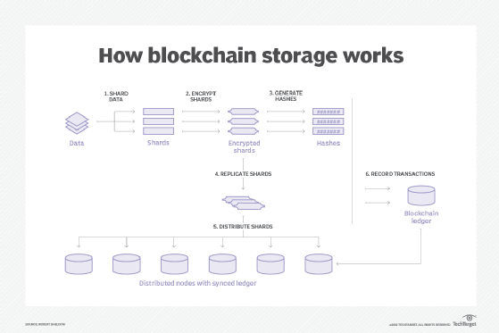

**Mining and incentive models**

Mining is the process of adding transaction details to the Blockchain, like sender address, hash value, etc. The Blockchain contains all the history of the transactions that have taken place in the past for record purposes and it is stored in such a manner that, it can’t be manipulated.

An Incentive is basically a reward given to a Blockchain Miner for speeding up the transactions and making correct decisions while processing the complete transaction securely.

# **Blockchain Incentives to Miners**

Bitcoin Mining is the process of adding important transaction details of Bitcoin to the Blockchain, like sender address, hash value, etc. The Blockchain contains all the history of the transactions that have taken place in the past for record purposes and it is stored in such a manner that, it can’t be manipulated.

An Incentive is basically a reward given to a Blockchain Miner for speeding up the transactions and making correct decisions while processing the complete transaction securely.

### **How Bitcoin Mining Works**

Bitcoin Mining works in the following ways:

* Mining needs high computational power and resources to solve difficult mathematical algorithms in order to add the transaction records successfully to the Blockchain.
* The process of discovering a new Bitcoin is simply called Mining and Miners tend to find new Bitcoins by solving difficult and complex algorithms.
* Each Miner across the world uses the computational resources and power he has to process the transactions and add the records to the Blockchain. Bitcoin is designed by its creator to mine every new Bitcoin every 10 minutes.
* Since all Bitcoin Miners contribute their computational power for processing the transactions, they get a reward in return. All those Miners who solve the complex algorithms are awarded in terms of Bitcoin digital currency.

### **Incentives of Bitcoin Mining**

* At a particular time, the miner has a large number of transactions that need to be processed.
* Also, a sender can send only some necessary information about the transaction since the maximum block size is already predefined by the system. Hence, to make the work of Miner easier by sending only relevant information to make the entire process faster.
* For incentivizing the Miner for his correct decisions during the transactions, the sender generally sends some incentives (rewards) in form of the cryptocurrency, in which the transaction takes place. It is generally a small percentage of the whole transaction that takes place.
* For Example – For a $250 Bitcoin transaction, the sender may send the incentive to the Miner of about $15 in Bitcoin.
* From the past years, the Blockchain Incentive to Miners has continuously declined as the Incentive is completely dependent on the transaction fees of the cryptocurrency. For the time, when the transaction volume of the Blockchains decline, then the transaction fees also declines, making it difficult to compensate the Miners for their work and their computational resources.

### **Block Rewards**

* A Block Reward is basically a reward given to a Bitcoin Miner for every Block for which he has solved the complex mathematical algorithm, and thus, the transaction records are added to the Blockchain.
* Halving Process is associated with Bitcoin that the Block Reward just halves itself once every 2016 Blocks are mined, every 4 years.
* Bitcoin every 4 years-
  + **2012-** 25.00 BTC.
  + **2016-** 12.50 BTC.
  + **2020-**  6.25 BTC.

### **Incentive Pools**

An Incentive Pool for Blockchain works in the following ways :

* A group of Miners tends to form an Incentive Pool so that, they can create blocks together for validating transactions, and then share the Incentives among all the Miners with equality.
* When a Pool Miner finds out the solution of the block header, he cannot mess with that transaction without removing the validation from it.

Finally, Incentives to Blockchain Miners act as a reward for them to carry out the transactions properly and to motivate them as well for future transactions. It is also good for the Miners as well as to maintain the Blockchain protocol within the decentralized system. But, Miners tend to maximize their profit by using imaginative methods to temper with the Blockchain Protocol system. So, in the future, there are a whole lot of ways for improvement in incentivizing the Miners.

**What Is Consensus in Blockchain?**

Consensus is the process by which a group of peers — known as ‘nodes’ — on a network determine which blockchain transactions are valid and which are not. Consensus mechanisms are the methodologies used to achieve this agreement. It’s these sets of rules that help to protect networks from malicious behaviour and hacking attacks.

There are many different types of consensus mechanisms, depending on the blockchain and its application. While they differ in their energy usage, security, and scalability, they all share one purpose: to ensure that records are true and honest. Here’s an overview of some of the best-known types of consensus mechanisms used by distributed systems to reach consensus.

**Types of Consensus Mechanisms**

**Proof of Work (PoW)**

Used by Bitcoin and many other public blockchains, Proof of Work (PoW) was the very first consensus mechanism created. It is generally regarded as the most reliable and secure of all the consensus mechanisms, though concerns over scalability are rife. While the term ‘proof of work’ was first coined in the early 1990s, it was Bitcoin founder Satoshi Nakamoto who first applied the technology in the context of digital currencies.

In PoW, ‘miners’ essentially compete against one another to solve extremely complex computational puzzles using high-powered computers. The first to come up with the 64-digit hexadecimal number (‘hash’) earns the right to form the new block and confirm the transactions. The successful miner is also rewarded ​​with a predetermined amount of crypto, known as a ‘block reward’.

As it requires large amounts of computational resources and energy in order to generate new blocks, the operating costs behind PoW are notoriously high. This acts as a barrier of entry for new miners, leading to concerns about centralisation and scalability limitations.

But it’s not just the costs that are high. The most common criticism of PoW is the impact the electrical consumption has on the environment. This has led many to seek more sustainable, energy-efficient consensus protocols, such as Proof of Stake (PoS)

**Proof-of-stake based**

Ethereum now uses a **proof-of-stake (PoS)** based consensus protocol.

**Block creation**

Validators create blocks. One validator is randomly selected in each slot to be the block proposer. Their consensus client requests a bundle of transactions as an 'execution payload' from their paired execution client. They wrap this in consensus data to form a block, which they send to other nodes on the Ethereum network. This block production is rewarded in ETH. In rare cases when multiple possible blocks exist for a single slot, or nodes hear about blocks at different times, the fork choice algorithm picks the block that forms the chain with the greatest weight of attestations (where weight is the number of validators attesting scaled by their ETH balance).

**Security**

A proof-of-stake system is secure crypto-economically because an attacker attempting to take control of the chain must destroy a massive amount of ETH. A system of rewards incentivizes individual stakers to behave honestly, and penalties disincentivize stakers from acting maliciously.

**What is a fork?**

**Definition**

Cryptocurrencies like Bitcoin and Ethereum are powered by decentralized, open-source software called a blockchain. A fork happens whenever a community makes a change to the blockchain’s protocol, or basic set of rules.

Cryptocurrencies like Bitcoin and Ethereum are powered by decentralized, open software that anyone can contribute to called a blockchain. They’re called blockchains because they’re literally made up of blocks of data – picture a *really* long train – that can be traced all the way back to the first-ever transaction on the network. And because they are open source, they rely on their communities to maintain and develop their underlying code.

A fork happens whenever a community makes a change to the blockchain’s protocol, or basic set of rules. When this happens, the chain splits — producing a second blockchain that shares all of its history with the original, but is headed off in a new direction.

**Why is this important?**

Most digital currencies have independent development teams responsible for changes and improvements to the network, much in the same way that changes to internet protocols allow web browsing to become better over time. So sometimes a fork happens to make a cryptocurrency more secure or add other features.

But it’s also possible for the developers of a new cryptocurrency to use a fork to create entire new coins and ecosystems.

* **Soft fork:** Think of a soft fork as a software upgrade for the blockchain. As long as it’s adopted by all users, it becomes a currency’s new set of standards. Soft forks have been used to bring new features or functions, typically at the programming level, to both Bitcoin and Ethereum. Because the end result is a single blockchain, the changes are backward-compatible with the pre-fork blocks.
* **Hard fork:** A hard fork happens when the code changes so much the new version is no longer backward-compatible with earlier blocks. In this scenario, the blockchain splits in two: the original blockchain and new version that follows the new set of rules. This creates an entirely new cryptocurrency – and is the source of many well-known coins. Cryptocurrencies like Bitcoin Cash and Bitcoin Gold evolved out of the original Bitcoin blockchain via hard fork.



**Why do forks occur?**

Just like all software needs upgrades, blockchains are updated for a variety of reasons:

* To add functionality
* To address security risks
* To resolve a disagreement within the community about the cryptocurrency’s direction

**Understanding a Hard Fork**

A hard fork is when nodes of the newest version of a blockchain no longer accept the older version(s) of the blockchain; which creates a permanent divergence from the previous version of the blockchain.

Adding a new rule to the code essentially creates a fork in the blockchain: one path follows the new, upgraded blockchain, and the other path continues along the old path. Generally, after a short time, those on the old chain will realize that their version of the blockchain is outdated or irrelevant and quickly upgrade to the latest version.

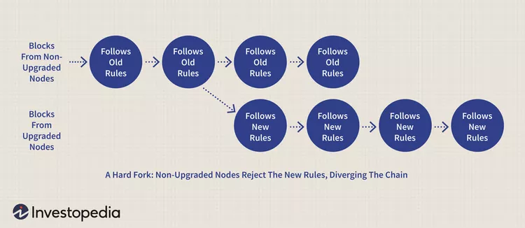

**Hard Forks vs. Soft Forks**

Hard forks and soft forks are essentially the same in the sense that when a cryptocurrency platform's existing code is changed, an old version remains on the network while the new version is created.

With a soft fork, only one blockchain will remain valid as users adopt the update. Whereas with a hard fork, both the old and new blockchains exist side by side, which means that the software must be updated to work by the new rules. Both forks create a split, but a hard fork creates two blockchains and a soft fork is meant to result in one.

Considering the differences in security between hard and soft forks, almost all users and developers call for a hard fork, even when a soft fork seems like it could do the job. Overhauling the blocks in a blockchain requires a tremendous amount of computing power, but the privacy gained from a hard fork makes more sense than using a soft fork.

**What Is Cryptocurrency?**

A cryptocurrency is a digital or virtual currency secured by cryptography, which makes it nearly impossible to counterfeit or double-spend. Most cryptocurrencies exist on decentralized networks using blockchain technology—a distributed ledger enforced by a disparate network of computers.

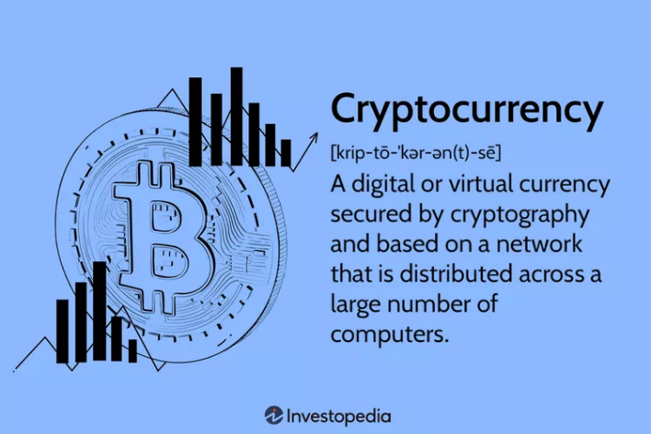

OR

Cryptocurrency (or “crypto”) is a digital currency, such as Bitcoin, that is used as an alternative payment method or speculative investment. Cryptocurrencies get their name from the cryptographic techniques that let people spend them securely without the need for a central government or bank.

Here are a few examples:

* [Bitcoin](https://www.nerdwallet.com/article/investing/what-is-bitcoin) was initially developed primarily to be a form of payment that isn't controlled or distributed by a central bank. While financial institutions have traditionally been necessary to verify that a payment has been processed successfully, Bitcoin accomplishes this securely, without that central authority.
* [Ethereum](https://www.nerdwallet.com/article/investing/ethereum) uses the same underlying technology as Bitcoin, but instead of strictly peer-to-peer payments, the cryptocurrency is used to pay for transactions on the Ethereum network. This network, built on the Ethereum [blockchain](https://www.nerdwallet.com/article/investing/blockchain), enables entire financial ecosystems to operate without a central authority. To visualize this, think insurance without the insurance company, or real estate titling without the title company.
* Scores of [altcoins](https://www.nerdwallet.com/article/investing/what-are-altcoins) (broadly defined as any cryptocurrency other than Bitcoin) arose to capitalize on the various — and at times promising — use cases for blockchain technology

**Why do people invest in cryptocurrencies?**

People invest in cryptocurrencies for the same reason anyone invests in anything. They hope its value will rise, netting them a profit.

If demand for Bitcoin grows, for example, the interplay of supply and demand could push up its value.

If people began using Bitcoin for payments on a huge scale, demand for Bitcoin would go up, and in turn, its price in dollars would increase. So, if you'd purchased one Bitcoin before that increase in demand, you could theoretically sell that one Bitcoin for more U.S. dollars than you bought it for, making a profit.

The same principles apply to Ethereum. "Ether" is the cryptocurrency of the Ethereum blockchain, where developers can build financial apps without the need for a third-party financial institution. Developers must use Ether to build and run applications on Ethereum, so theoretically, the more that is built on the Ethereum blockchain, the higher the demand for Ether.

However, it's important to note that to some, cryptocurrencies aren't investments at all. Bitcoin enthusiasts, for example, hail it as a much-improved monetary system over our current one and would prefer we spend and accept it as everyday payment. One common refrain — "one Bitcoin is one Bitcoin" — underscores the view that Bitcoin shouldn't be measured in USD, but rather by the value it brings as a new monetary system.

**How does cryptocurrency work?**

Cryptocurrencies are supported by a technology known as blockchain, which maintains a tamper-resistant record of transactions and keeps track of who owns what. The use of blockchains addressed a problem faced by previous efforts to create purely digital currencies: preventing people from making copies of their holdings and attempting to spend it twice

Individual units of cryptocurrencies can be referred to as coins or tokens, depending on how they are used. Some are intended to be units of exchange for goods and services, others are stores of value, and some can be used to participate in specific software programs such as games and financial products.

**What is cryptography?**

Cryptography provides for secure communication in the presence of malicious third-parties—known as adversaries. Encryption uses an algorithm and a key to transform an input (i.e., plaintext) into an encrypted output (i.e., ciphertext). A given algorithm will always transform the same plaintext into the same ciphertext if the same key is used. Algorithms are considered secure if an attacker cannot determine any properties of the plaintext or key, given the ciphertext. An attacker should not be able to determine anything about a key given a large number of plaintext/ciphertext combinations which used the key.

## What is the difference between symmetric and asymmetric cryptography?

With symmetric cryptography, the same key is used for both encryption and decryption. A sender and a recipient must already have a shared key that is known to both. Key distribution is a tricky problem and was the impetus for developing asymmetric cryptography.

With asymmetric crypto, two different keys are used for encryption and decryption. Every user in an asymmetric cryptosystem has both a public key and a private key. The private key is kept secret at all times, but the public key may be freely distributed.

Data encrypted with a public key may only be decrypted with the corresponding private key. So, sending a message to John requires encrypting that message with John’s public key. Only John can decrypt the message, as only John has his private key. Any data encrypted with a private key can only be decrypted with the corresponding public key. Similarly, Jane could digitally sign a message with her private key, and anyone with Jane’s public key could decrypt the signed message and verify that it was in fact Jane who sent it.

Symmetric is generally very fast and ideal for encrypting large amounts of data (e.g., an entire disk partition or database). Asymmetric is much slower and can only encrypt pieces of data that are smaller than the key size (typically 2048 bits or smaller). Thus, asymmetric crypto is generally used to encrypt symmetric encryption keys which are then used to encrypt much larger blocks of data. For digital signatures, asymmetric crypto is generally used to encrypt the hashes of messages rather than entire messages.

A cryptosystem provides for managing cryptographic keys including generation, exchange, storage, use, revocation, and replacement of the keys.

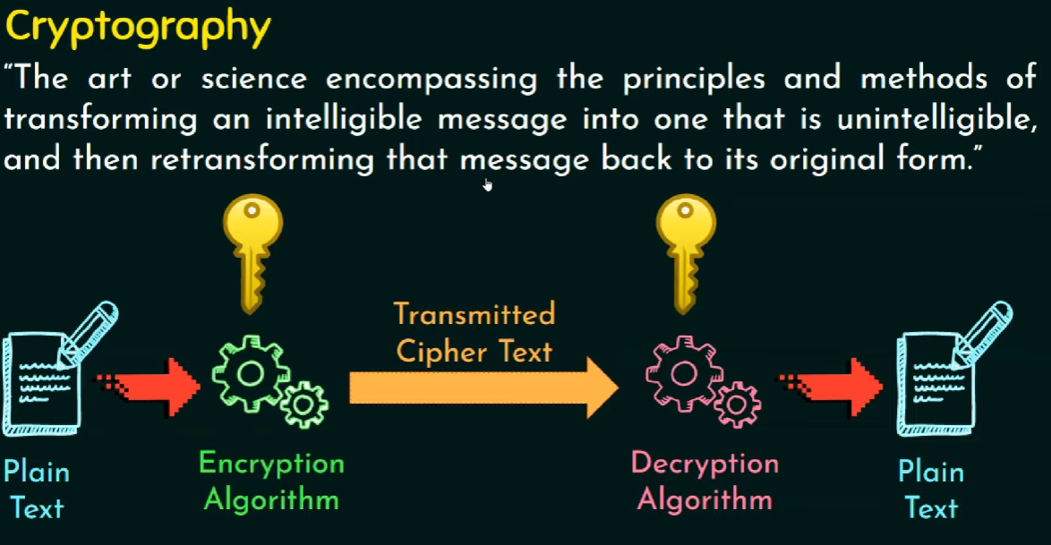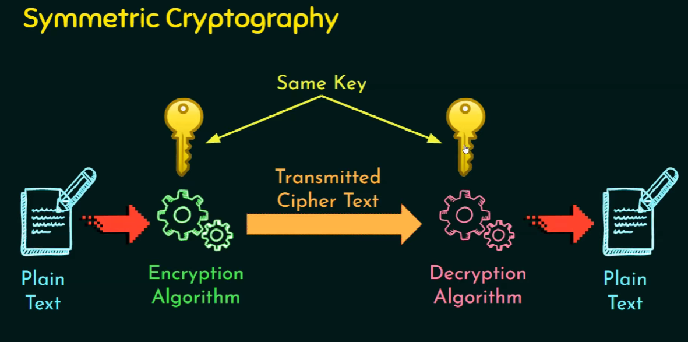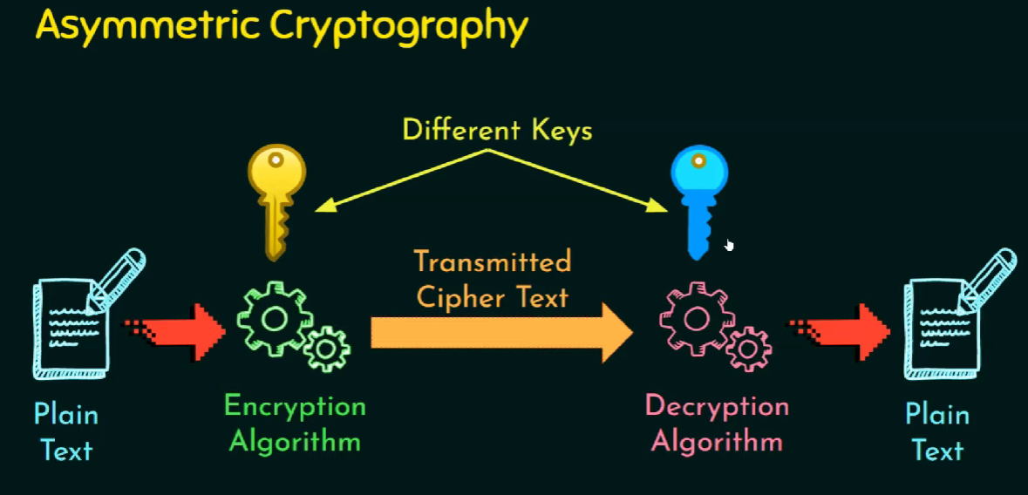

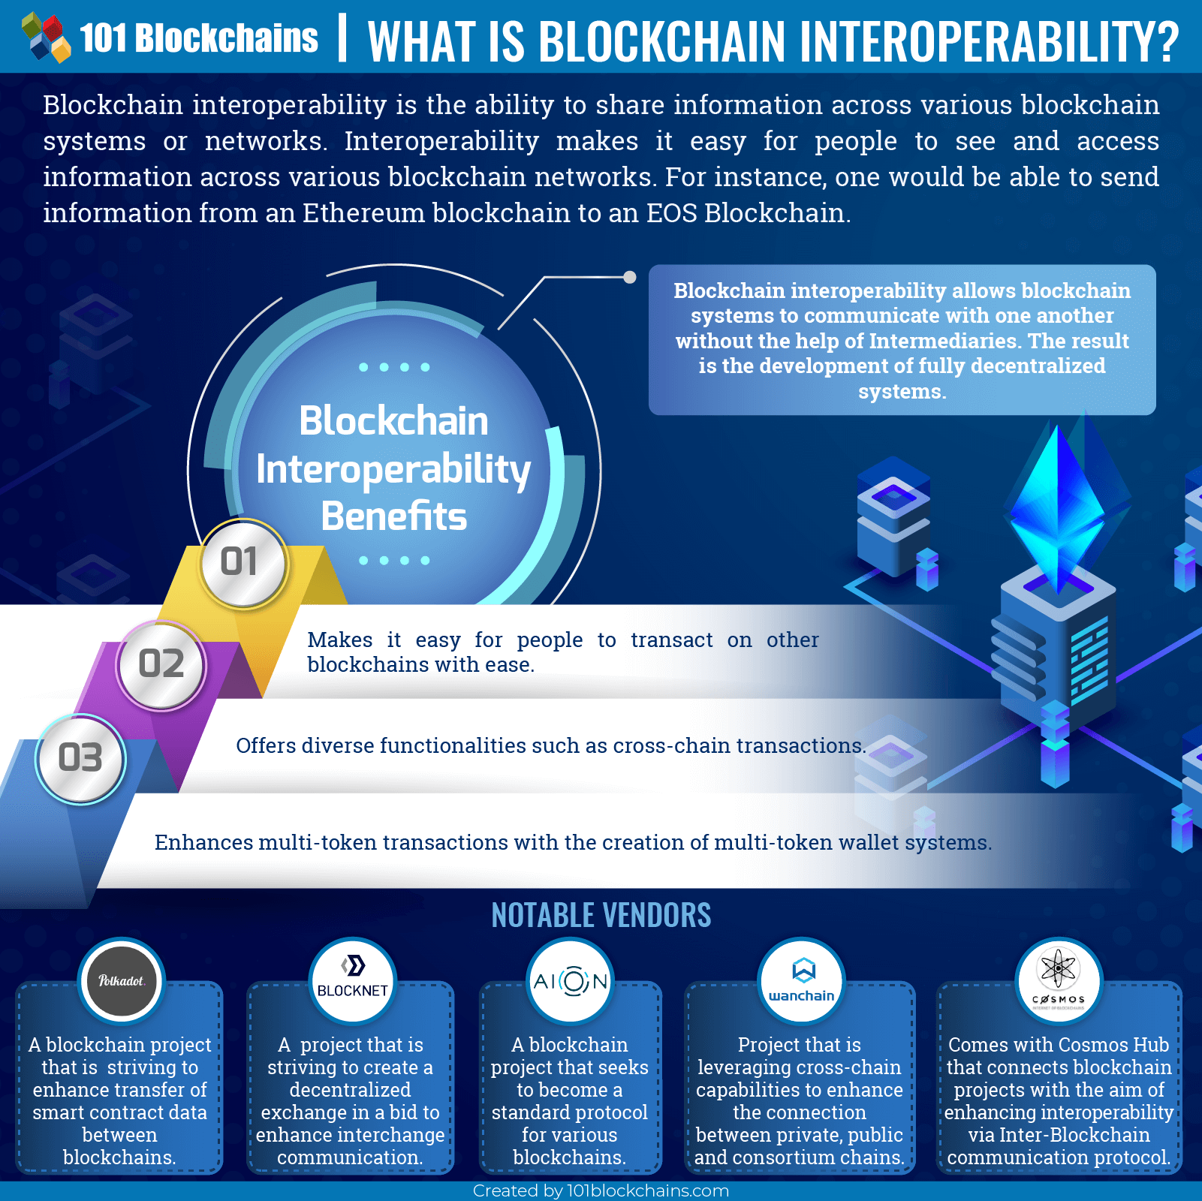

**What is cross-chain technology?**

As far as the need for enhancing interoperability between blockchains is concerned, cross-chain technology is one of the most effective solutions to facilitate the same. It is an emerging technology that facilitates the transfer of value and data between two or more blockchains networks.

The rapid increase in applications of some of the most common networks including Bitcoin Ethereum and Solana has led to the emergence of several key issues. While these networks enable a user to trade their tokens on the blockchain, there are several underlying economical and technical limitations while scaling up. As a result of these constraints, the users are usually not able to get the full benefits of technology because these chains operate separately. However, the introduction of cross-chain technology solves these problems by facilitating **blockchain interoperability**and enabling users to communicate and share data.

 The cross-chain protocol facilitates interoperability between different blockchain networks and enables the exchange of data between several networks. Through cross-chain protocol, users can communicate without the involvement of intermediaries. Consequently, blockchains that share similar networks can transfer value and data between each other.

**Following are several main features of the cross-chain technology –**

 Cross-chain technology works on the principle of atomicity.

* It enables proper consistency between several interconnected blockchains.
* It enables the distribution of networks across various platforms.

**EVM(Ethereum Virtual Machine) follow the give link below :**

<https://moralis.io/evm-explained-what-is-ethereum-virtual-machine/>

**What is Ethereum?**

Ethereum is software running on a network of computers that ensures that data and small computer programs called smart contracts are replicated and processed on all the computers on the network, without a central coordinator. The vision is to create an unstoppable censorship-resistant self-sustaining decentralised world computer. The official website is [https://www.ethereum.org](https://www.ethereum.org/)

It extends the blockchain concepts from Bitcoin which validates, stores, and replicates transaction data on many computers around the world (hence the term ‘distributed ledger’). Ethereum takes this one step further, and also runs computer code equivalently on many computers around the world.

What Bitcoin does for distributed data storage, Ethereum does for distributed data storage plus computations. The small computer programs being run are called smart contracts, and the contracts are run by participants on their machines using a sort of operating system called a “Ethereum Virtual Machine”.

## How is Ethereum different to Bitcoin?

This is where it gets more technical and in many ways more complex.

### **Ethereum’s block time is shorter**

In Ethereum the time between blocks is around 14 seconds, compared with Bitcoin’s ~10 minutes. This means that on average if you made a Bitcoin transaction and an Ethereum transaction, the Ethereum transaction would be recorded into Ethereum’s blockchain faster than the Bitcoin transaction getting into Bitcoin’s blockchain. You could say Bitcoin writes to its database roughly every 10 minutes, whereas Ethereum writes to its database roughly every 14 seconds.

### **Ethereum has smaller blocks**

In Bitcoin, the maximum block size is specified in bytes (currently 1 MB) whereas Ethereum’s block size is based on complexity of contracts being run – it’s known as a Gas limit per block, and the maximum can vary slightly from block to block.

Currently the maximum block size in Ethereum is around 1,500,000 Gas. Basic transactions or payments of ETH from one account to another (ie not a smart contract) have a complexity of 21,000 Gas so you can fit around 70 transactions into a block (1,500,000 / 21,000). In Bitcoin you currently get around 1,500-2,000 transactions in a block.

Data-wise currently most Ethereum blocks are under 2 KB in size.

### **The Ethereum Virtual Machine can run smart contracts**

Compared with Bitcoin’s primitive scripting language, the code that can be deployed in Ethereum and run as smart contracts is more advanced and familiar to developers. Smart contract code is run by something called the Ethereum Virtual Machine, which runs on the computers of all participants on the network. If you are familiar with Microsoft Excel macros (pieces of code run by Excel), then similarly smart contracts are pieces of code run by Ethereum’s Virtual Machine.

In many descriptions, Ethereum smart contracts are called “Turing complete”. This means that they are fully functional and can perform any computation that you can do in any other programming language.

### **ETH token issuance**

How are ETH tokens printed or created? The biggest difference between ETH and BTC token generation is that BTC generation halves approximately every 4 years whereas ETH generation continues to be generated at a constant number every year (perhaps only until the Serenity version).

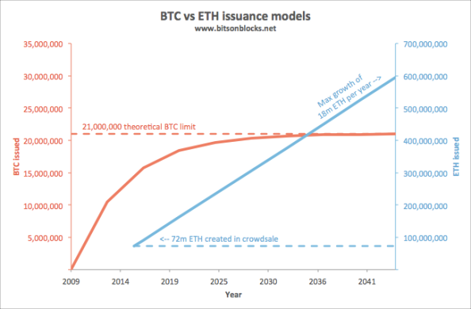

This is a lot more complicated than Bitcoin. In summary, the number of ETH in existence are:

*Pre-mine + Block rewards + Uncle rewards + Uncle referencing rewards*

#### Pre-mine

Around 72 million ETH were created for the crowdsale in July/Aug 2014. This is sometimes called a ‘pre-mine’. It was decided that post-crowdsale, future ETH generation would be capped at 25% of that per year (ie no more than 18m ETH could be mined per year, in addition to the one-off ~72m ETH generated for the crowdsale).

#### Block reward

Currently each block mined creates 5 fresh ETH. Doing the maths, if a block is mined every 14 seconds, and there are 31.5m seconds in a year (365x24x60x60), this means 2.25m blocks are mined per year. 2.25m blocks at 5 ETH per block = 11.3m ETH generated per year. This meets the commitment of less than 18m ETH generated per year.

#### Uncle reward

Actually it’s a little more than that. Some blocks are mined a little late and don’t form part of the main blockchain. In Bitcoin these are called ‘orphans’ and are entirely discarded, but in Ethereum they are called ‘uncles’ and can be referenced by later blocks. If uncles are referenced as uncles by a later block, they create about 4.375 ETH for the miner of the uncle (7/8th of the full 5 ETH reward). This is called the uncle reward. Currently around 500 uncles are created per day, adding an additional 2,000 ETH into circulation per day (~0.7m ETH per year at this rate).

#### Uncle referencing reward

And there’s a bit more too: A miner who references an uncle also gets about 0.15 ETH per uncle (maximum 2 uncles).

This model described above, where valid blocks are determined and miners are rewarded, is called the Ghost protocol (Greedy Heaviest-Observed Sub-Tree).

### **Future changes to ETH generation**

It hasn’t really been decided yet what happens to issuance when Ethereum moves from Proof-of-Work (including the Ghost issuance rules) to Proof-of-Stake as the block-addition mechanism. The Proof-of-Stake mechanism will use a protocol called Casper (yes, as in the friendly ghost. Who says crypto nerds don’t have a sense of humour?). The rate of ETH issuance under Casper may very well be lower than it is now under Ghost.

### **Mining rewards**

So, what do miners get for mining?

In Bitcoin, the miner of a block receives:

* 12.5 new BTC (currently. See [a gentle introduction to bitcoin mining](http://bitsonblocks.net/2015/09/21/a-gentle-introduction-to-bitcoin-mining/) for more detail), plus
* transaction fees from the transactions included in the block

In Ethereum, the miner of a block receives:

* 5 new ETH block reward (0r 4.375 new ETH for an uncle), plus
* a small new reward for referencing up to 2 recent uncles (1/32 of a block reward ie 1/32 x 5 ETH = 0.15625 new ETH per uncle), plus
* gas from contracts that were run during the block

Currently the average block has a gas limit of 1,500,000 Gas, and the network has an average Gas Price of 0.000 000 022 ETH, meaning that a miner might make 0.033 ETH in a ‘full’ block as the Gas reward. Note that the Gas from contracts are payments of existing ETH, not new ETH being created.

### **Gas and Gas Price**

When you activate a smart contract, you ask all the miners in the whole network to each individually perform the calculations within it. This costs them time and energy, and Gas is the mechanism by which you pay them for that service.

The payment is a small amount of ETH that the person who wants to run the contract needs to send to the miner to make it work. This is similar to putting a coin in a jukebox.

*Payment (in ETH) = Gas amount (in Gas) x Gas price (in ETH/Gas)*

#### Gas amount

The more complex the smart contract (the number and type of computational steps, memory used for storage, etc), then the more Gas the contract requires to run and complete. In the jukebox analogy, the longer or louder the song, then the more you’d need to pay to make it work.

#### Gas Price

Whereas the amount of Gas to run a contract is fixed for any specific contract, as determined by the complexity of the contract, the Gas Price is specified by the person who wants the contract to run, at the time they request it (a bit like Bitcoin transaction fees). Each miner will look at how generous the gas price is, and will determine whether they want to run the contract as part of the block. If you want miners to run your contract, you offer a high Gas Price. In this way it’s a competitive auction driven by how much someone is willing to pay to have a contract run.

#### Why Gas?

Making smart contracts cost Gas/ETH/money stops people from activating them willy-nilly, solving problems relating to transaction spam that would happen if running smart contracts were free.

### **ETH Units**

Just like 1 dollar can be split into 100 cents, and 1 BTC can be split into 100,000,000 satoshi, Ethereum too has its own unit naming convention.

The smallest unit is a wei and there are 1,000,000,000,000,000,000 of them per ETH. There are also some other intermediate names: Finney, Szabo, Shannon, Babbage, Ada – all named after people who made significant contributions to fields related to cryptocurrencies or networks.

Wei and Ether are the two most common denominations.

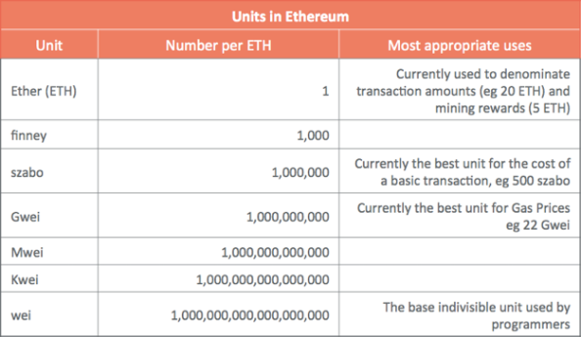

**Smart Contract languages: Solidity / Serpent, LLL**

There are three common languages smart contracts are written in, which can be compiled into smart contracts and run on Ethereum Virtual Machines. They are:

* **Solidity** – similar to the language Javascript. This is currently the most popular and functional smart contract scripting language.
* **Serpent** – similar to the language Python, and was popular in the early history of Ethereum.
* **LLL** (Lisp Like Language) – similar to Lisp and was only really used in the very early days. It is probably the hardest to write in.

**Ethereum software: geth, eth, pyethapp**

The official Ethereum clients are all open source – that is you can see the code behind them, and tweak them to make your own versions. The most popular clients are:

**geth** (written in a language called Go) <https://github.com/ethereum/go-ethereum>

**eth** (written in C++) <https://github.com/ethereum/cpp-ethereum>

**pyethapp** (written in Python) <https://github.com/ethereum/pyethapp>

These are all command-line based programs (think green text on black backgrounds) and so additional software can be used for a nicer graphical interface. Currently the official and most popular graphical one is Mist (<https://github.com/ethereum/mist>) , which runs on top of geth or eth.

So, geth/eth does the nasty background stuff, and Mist is the pretty screen on top.

**Polygon**

Polygon (formerly known as Matic Network) is a protocol for building and connecting Ethereum-compatible blockchain networks. It is designed to provide faster and cheaper transactions on the Ethereum network by using side chains and an adapted version of the Plasma framework.

**History of Polygon (MATIC) Crypto**

The history of Polygon Matic dates back to 2017 when the project was founded by Jaynti Kanani and Sandeep Nailwal. In 2021, the project took up a rebranding and went from Matic Network to Polygon. This was done in the light of reflecting a broader focus on providing infrastructure for a wide range of blockchain use cases.

With Polygon MATIC, users can easily create and manage their own decentralized applications, securely store and transfer assets, and even trade digital assets. With its powerful features and benefits, Polygon MATIC can be a great tool for you to leverage the power of the blockchain. Find out how it can benefit you in the best ways possible below.

**Benefits of Polygon**

Polygon MATIC has several benefits that make it a great blockchain solution. Here are a few of its top benefits that you need to be aware of:

* **Scalability** - Polygon MATIC has high scalability and can support millions of users and transactions. It can also scale at a very low cost. This means that it can handle high transaction volumes and can support a large user base.
* **Security** - Polygon MATIC is a secure platform with state-of-the-art security features. You can easily secure your data and transactions on the platform through the use of the platform’s security features.
* **Wide range of services and tools** - Polygon MATIC offers a wide range of services and tools that can benefit different types of users. Whether you are a developer, an individual, or a business, Polygon MATIC can help you with your decentralized applications and smart contracts.
* **Cost-effective and scalable solutions** - With Polygon MATIC, you can easily and cost-effectively deploy various decentralized applications. It also offers scalable solutions that can grow and evolve with your business.

**Polygon vs. Ethereum**

Polygon is a secondary scaling solution that is compatible with and complements the Ethereum blockchain. Polygon aims to improve upon Ethereum as a blockchain development network. Polygon complements Ethereum by providing additional features relating to security, blockchain sovereignty, user and developer experience, and modularity.

Both Ethereum and Polygon use a modified proof-of-stake mechanism that enables transactions to be processed quickly and cheaply. (Ethereum officially switched to a proof-of-stake consensus mechanism in 2022.)

**Future of Polygon**

Polygon launched Polygon Studios, a subsidiary of Polygon that focuses on blockchain gaming and [non-fungible tokens](https://www.investopedia.com/non-fungible-tokens-nft-5115211) (NFTs), in 2021.11 Polygon Studios, if successful, could establish Polygon as a leading technology provider for decentralized gaming and NFTs.

In Jan. 2022, Polygon got a new chief executive officer (CEO). Ryan Watts has joined Polygon from YouTube, where he was the head of gaming

**How Much Are MATIC Coins Worth?**

For most of their history, Polygon's MATIC tokens have [traded](https://www.investopedia.com/terms/t/trade.asp) for less than 5 cents. MATIC's price has appreciated significantly but has remained below $3.00. MATIC was trading for around $0.75 as of September 22, 2022

**How Many Polygon Coins Are There?**

The maximum supply of MATIC is 10 billion [tokens](https://www.investopedia.com/terms/c/crypto-token.asp). The majority—8.73 billion MATIC—have already been issued.

**Polygon provides multiple solutions including**

* [Polygon zkEVM](https://polygon.technology/polygon-zkevm), a zk powered EVM equivalent L2
* [Polygon PoS](https://polygon.technology/polygon-pos), a proof of stake, EVM compatible side chain
* [Polygon CDK](https://polygon.technology/polygon-cdk), a Chain Development Kit for building customizable zk powered L2s
* [Polygon ID](https://polygon.technology/polygon-id), identity infrastructure and SDKs to facilitate trusted and secure relationships between apps and users

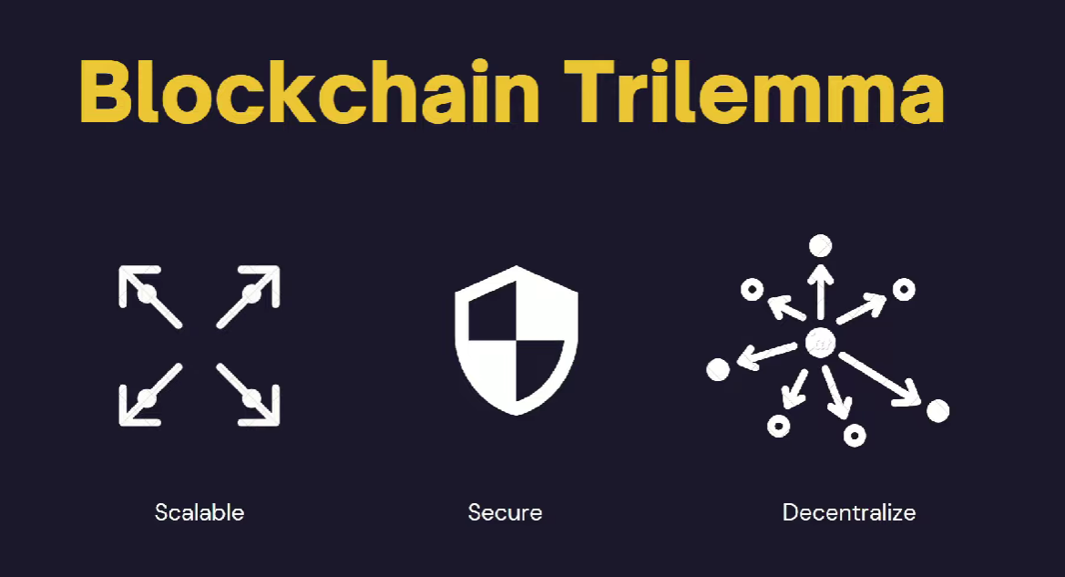

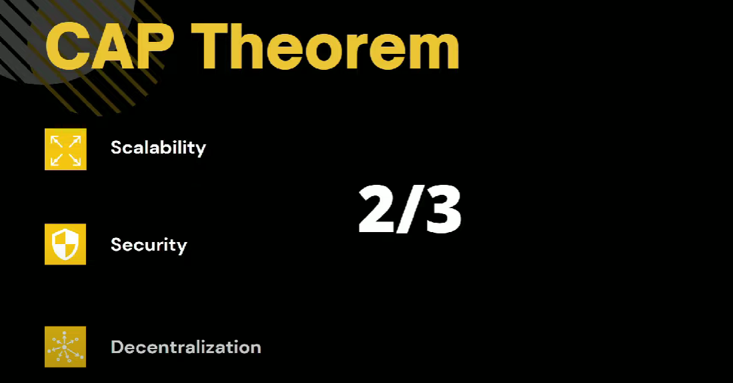

## What Is an Oracle Network?

Oracles provide a way for the decentralized Web3 ecosystem to access existing [data sources](https://blog.chain.link/understanding-how-data-and-apis-power-next-generation-economies/), legacy systems, and advanced computations. Decentralized oracle networks (DONs) enable the creation of [hybrid smart contracts](https://blog.chain.link/hybrid-smart-contracts-explained/), where onchain code and offchain infrastructure are combined to support advanced decentralized applications (dApps) that react to real-world events and interoperate with traditional systems.

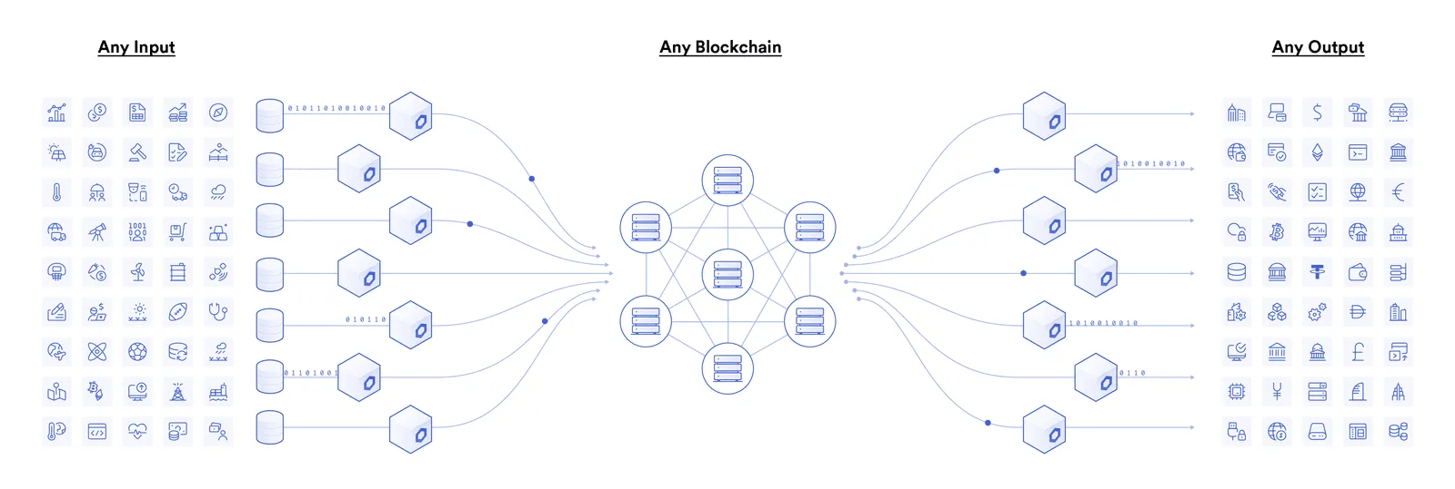

Blockchain oracles connect blockchains to inputs and outputs in the real world

For example, let’s assume Alice and Bob want to bet on the outcome of a sports match. Alice bets $20 on team A and Bob bets $20 on team B, with the $40 total held in escrow by a smart contract. When the game ends, how does the smart contract know whether to release the funds to Alice or Bob? The answer is it requires an oracle mechanism to fetch accurate match outcomes offchain and deliver it to the blockchain in a secure and reliable manner.

## Solving the Oracle Problem

The [blockchain oracle problem](https://blog.chain.link/what-is-the-blockchain-oracle-problem/) outlines a fundamental limitation of smart contracts—they cannot inherently interact with data and systems existing outside their native blockchain environment. Resources external to the blockchain are considered “offchain,” while data already stored on the blockchain is considered onchain. By being purposely isolated from external systems, blockchains obtain their most valuable properties like strong consensus on the validity of user transactions, prevention of [double-spending attacks](https://www.investopedia.com/terms/d/doublespending.asp), and mitigation of network downtime. Securely interoperating with offchain systems from a blockchain requires an additional piece of infrastructure known as an “oracle” to bridge the two environments.

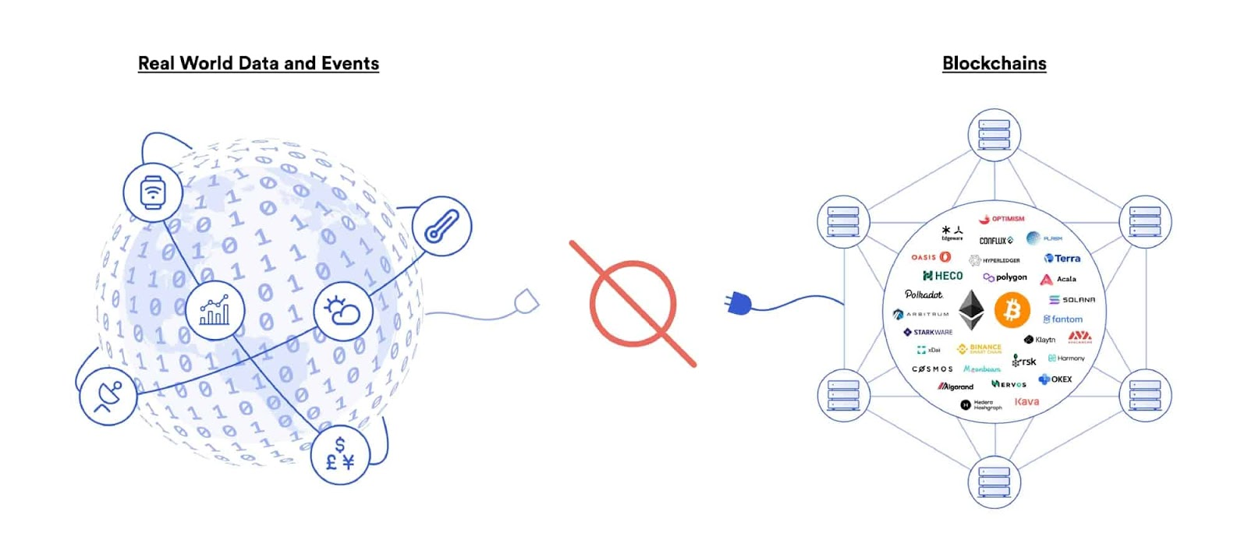

Blockchains cannot connect to real-world data and events on their own

Solving the oracle problem is of the utmost importance because the vast majority of [smart contract use cases](https://blog.chain.link/smart-contract-use-cases/) like DeFi require knowledge of real-world data and events happening offchain. Thus, crypto oracles expand the types of digital agreements that blockchains can support by offering a universal gateway to offchain resources while still upholding the valuable security properties of blockchains. Major industries benefit from combining oracles and smart contracts including asset prices for finance, weather information for insurance, randomness for gaming, IoT sensors for supply chain, ID verification for government, and much more.

Because the data delivered by oracles to blockchains directly determines the outcomes of smart contracts, it is critically important that the oracle mechanism is correct if the agreement is to execute exactly as expected.

**What Is the Oracle Problem?**

The oracle problem revolves around a very simple limitation—blockchains cannot pull in data from or push data out to any external system as built-in functionality. As such, blockchains are isolated networks, akin to a computer with no Internet connection. The isolation of a blockchain is the precise property that makes it extremely secure and reliable, as the network only needs to form consensus on a very basic set of binary (true/false) questions using data already stored inside of its ledger. These questions include: did the public key holder sign the transaction with their corresponding private key, does the public address have enough funds to cover its transaction, and is the type of transaction valid within the particular smart contract? The very narrow focus of blockchain consensus is why smart contracts are referred to as being deterministic—they execute exactly as written with a much higher degree of certainty than traditional systems.

However, for smart contracts to realize upwards of [90% of their potential use cases](https://blog.chain.link/smart-contract-use-cases/), they must connect to the outside world. For example, financial smart contracts need market information to determine settlements, insurance smart contracts need IoT and web data to make decisions on policy payouts, trade finance contracts need trade documents and digital signatures to know when to release payments, and many smart contracts want to settle in fiat currency on a traditional payment network. None of this information is inherently generated within the blockchain, nor are these traditional services directly accessible.

Bridging the connection between the blockchain (on-chain) and the outside world (off-chain) requires an additional and separate piece of infrastructure known as an oracle.

What Is a Blockchain Oracle?

A [blockchain oracle](https://chain.link/education/blockchain-oracles) is a secure piece of middleware that facilitates communication between blockchains and any off-chain system, including data providers, web APIs, enterprise backends, cloud providers, IoT devices, e-signatures, payment systems, other blockchains, and more. Oracles take on several key functions:

* **Listen** – monitor the blockchain network to check for any incoming user or smart contract requests for off-chain data.
* **Extract**– fetch data from one or multiple external systems such as off-chain APIs hosted on third-party web servers.
* **Format** – format data retrieved from external APIs into a blockchain readable format (input) and/or making blockchain data compatible with an external API (output).
* **Validate** – generate a cryptographic proof attesting to the performance of an oracle service using any combination of data signing, blockchain transaction signing, TLS signatures, Trusted Execution Environment (TEE) attestations, or zero-knowledge proofs.
* **Compute** – perform some type of secure off-chain computation for the smart contract, such as calculating a median from multiple oracle submissions or generating a [verifiable random number](https://chain.link/vrf) for a gaming application.
* **Broadcast** – sign and broadcast a transaction on the blockchain in order to send data and any corresponding proof on-chain for consumption by the smart contract.
* **Output (optional)** –  send data to an external system upon the execution of a smart contract, such as relaying payment instructions to a traditional payment network or triggering actions from a cyber-physical system.

Carrying out the functions above requires that the oracle system operate both on and off the blockchain simultaneously. The on-chain component is for establishing a blockchain connection (to listen for requests), broadcasting data, sending proofs, extracting blockchain data, and potentially performing computation on the blockchain. The off-chain component is for processing requests, retrieving and formatting external data, sending blockchain data to external systems, and performing off-chain computation for greater scalability, privacy, security, and various other smart contract enhancements.

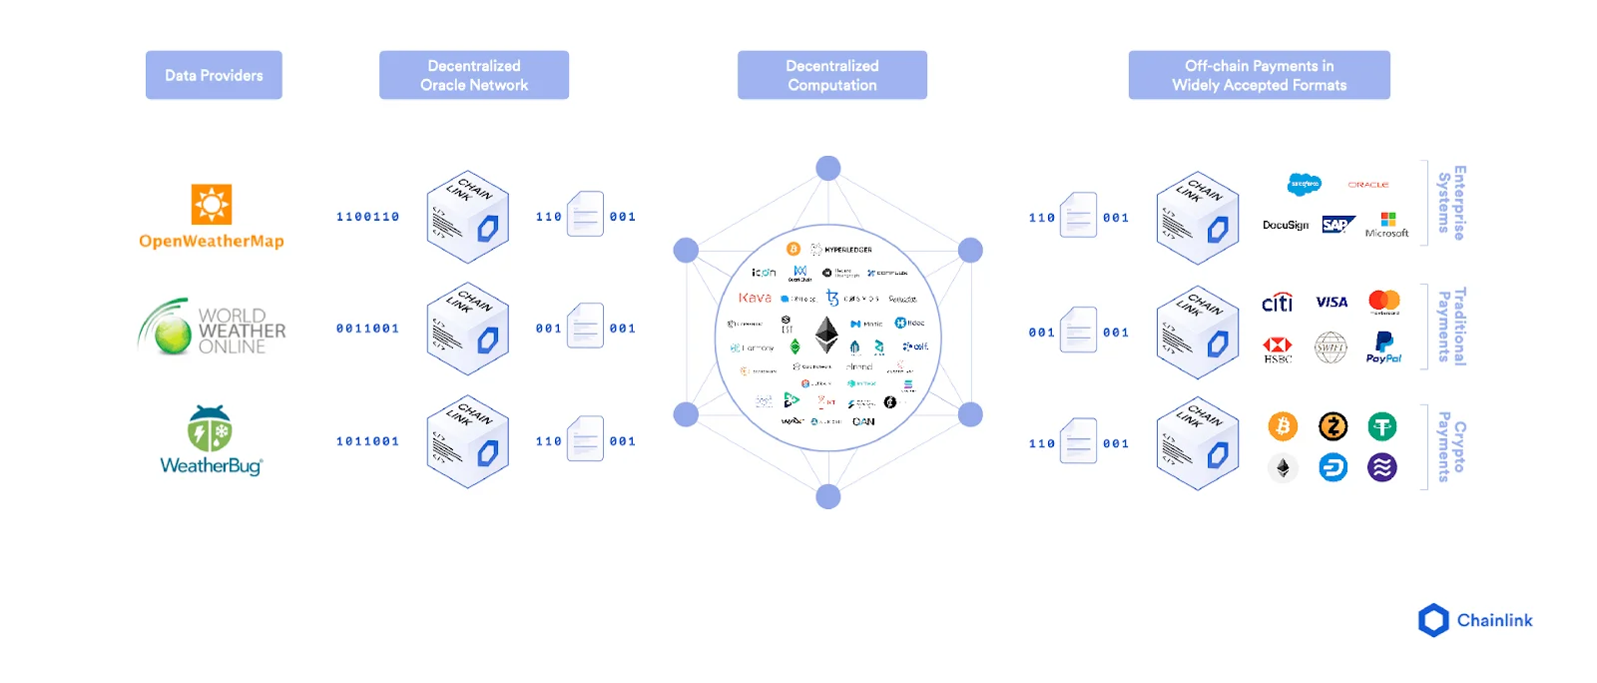

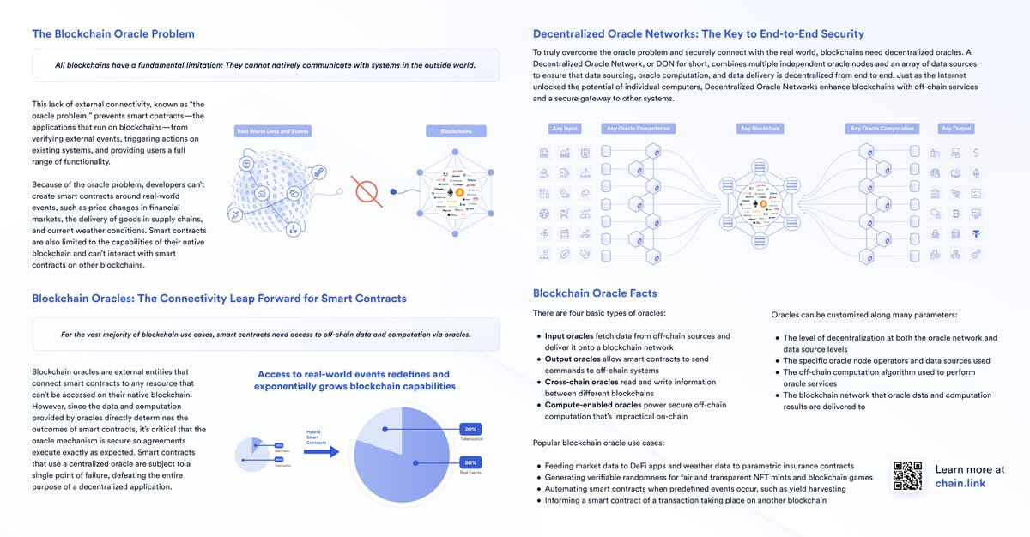



## Types of Blockchain Oracles

Given the extensive range of offchain resources, blockchain oracles come in many shapes and sizes. Not only do hybrid smart contracts need various types of external data and computation, but they require various mechanisms for delivery and different levels of security. Generally, each type of crypto oracle involves some combination of fetching, validating, computing upon, and delivering data to a destination.

### **Input Oracles**

The most widely recognized type of oracle today is known as an “input oracle,” which fetches data from the real-world (offchain) and delivers it onto a blockchain network for smart contract consumption. These types of oracles are used to power Chainlink Price Feeds, providing DeFi smart contracts with onchain access to financial market data.

### **Output Oracles**

The opposite of input oracles are “output oracles,” which allow smart contracts to send commands to offchain systems that trigger them to execute certain actions. This can include informing a banking network to make a payment, telling a storage provider to store the supplied data, or pinging an IoT system to unlock a car door once the onchain rental payment is made.

### **Cross-Chain Oracles**

Another type of oracle are cross-chain oracles that can read and write information between different blockchains. Cross-chain oracles enable interoperability for moving both data and assets between blockchains, such as using data on one blockchain to trigger an action on another or bridging assets cross-chain so they can be used outside the native blockchain they were issued on.

### **Compute-Enabled Oracles**

A new type of oracle becoming more widely used by smart contract applications are “compute-enabled oracles,” which use secure offchain computation to provide decentralized services that are impractical to do onchain due to technical, legal, or financial constraints. This can include using [Chainlink Automation](https://chain.link/automation) to trigger the running of smart contracts when predefined events take place, computing [zero-knowledge proofs](https://blog.chain.link/what-is-a-zero-knowledge-proof-zkp/) to generate data privacy, or running a [verifiable randomness function](https://blog.chain.link/chainlink-vrf-on-chain-verifiable-randomness/) to provide a tamper-proof and provably fair source of randomness to smart contracts.

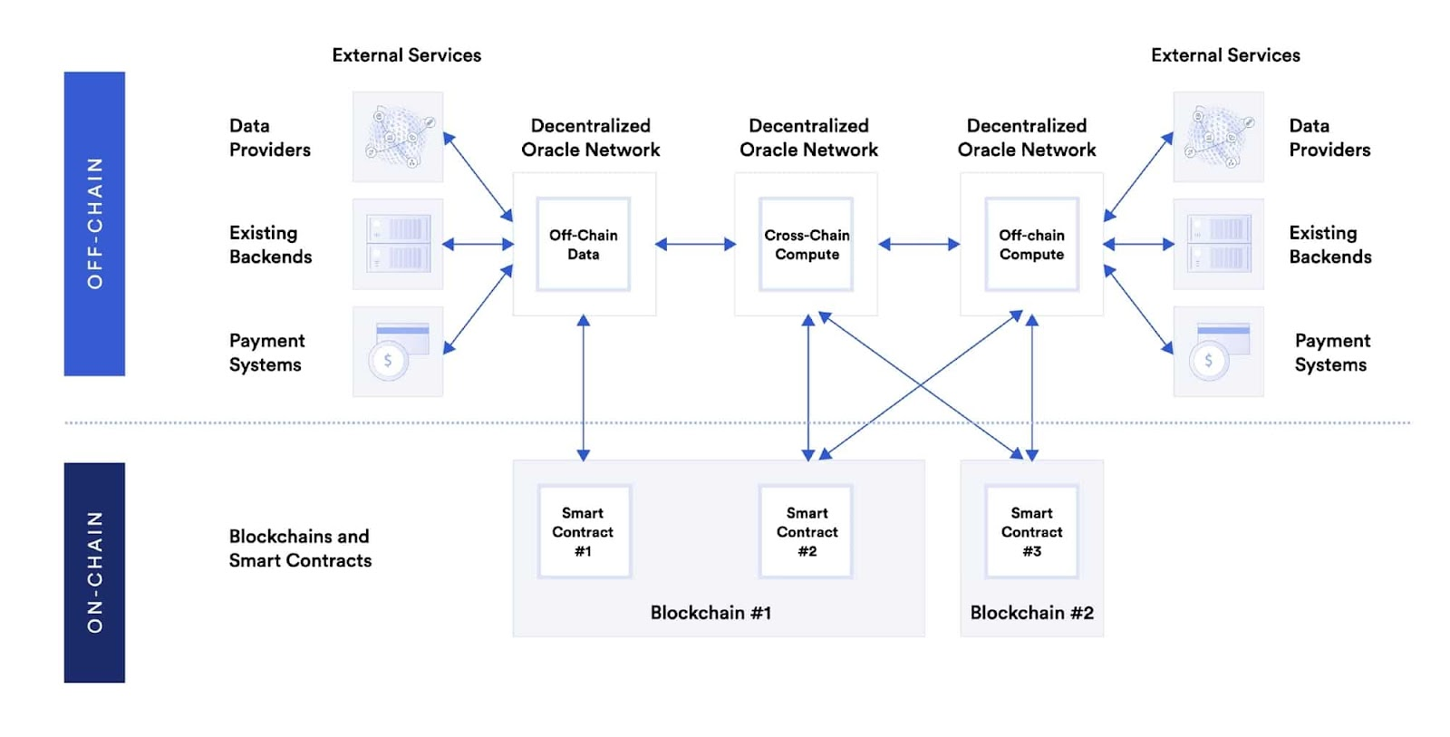

Different types of oracles enable the creation of hybrid smart contracts

**1. Why are hybrid smart contracts needed?**

It has been a while that the world has known and used Blockchain smart contracts to overcome the imperfection of the centralized contract systems prevalent in the business and legal ecosystem. Centralized contract systems are asymmetric because one of the involved parties always enjoys an unfair influence over the arbitration process. One party always has more money, time and a clear understanding of the contract enforcement infrastructure. Within the framework of such a centralized contract system, parties determine the trustworthiness of the counterparty based on its brand value. Thus, collaboration over centralized contract systems happened through brand-based trust, which lacks transparency and immutability.

Blockchain smart contracts have replaced brand-based trust with math-based trust. Be it hosting, execution, enforcement, or custody mechanisms, everything about smart contracts is blockchain-based. Thus, it purely runs on a decentralized network that any individual participant or agency cannot undermine. Yet, there is a glitch in smart contracts.

**1.1 The glitch in smart contracts**

Smart contracts are acknowledged as the most robust, immutable and verifiable contracts that automatically maintain the transparency, fairness and efficiency of contract obligations by executing an IF/THEN framework when conditions are met. However, there is a very peculiar glitch that limits down the functionality of smart contracts.

The data that defines the conditions of a smart contract traditionally comes from the Blockchain only. This means a smart contract can only read the data that exists in an on-chain programming language. Inability to read off-chain programing language restricts smart contract’s connectivity to real-world data sources. The introduction of Oracles into the crypto ecosystem resolved the problem. Oracle as a middleware (software) could translate the off-chain to on-chain data, thus making the real-world data systems and sources functional for the blockchain smart contracts. But, oracle is a centralized entity, so its data can be compromised. This puts up a concerning question-what is the benefit of having a smart contract on a decentralized blockchain if it is sourcing its data from a centralized oracle that can be made faulty?

Won’t that make the immutability and trustworthiness of a smart contract doubtful and questionable? This is the point when the need for hybrid smart contracts is realized. Chainlink is a platform to build hybrid smart contracts.

**1.2 What solution does the Chainlink hybrid smart contract provide?**

A Hybrid Smart contract is an ideal solution to address the reliability issues that might occur in using a single centralized oracle only. The hybrid smart contract maintains the essence of decentralization. It connects the Blockchain network of the smart contract not to a centralized oracle but to a Decentralized Oracle Network (DON). Blockchain and DON are two distinctly different computing environments, and both specialize in features that others do not. A hybrid Smart contract synchronizes them to build a sophisticated application capable of something that Blockchain and oracle couldn’t achieve alone

**2. What is the composition of a hybrid smart contract?**

A hybrid smart contract is an application made of two key components:

1) Smart contract— A code that runs exclusively on the Blockchain

2) Decentralized oracle network— A distributed network of oracle nodes that provide information from off-blockchain data sources to on-blockchain smart contracts.

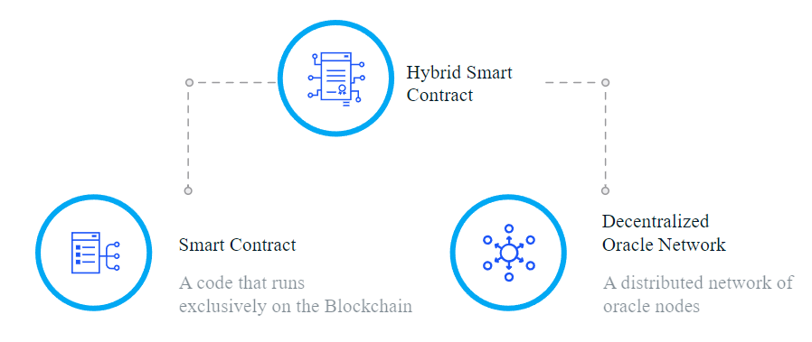

**Problem: Smart Contracts Can Reintroduce Counterparty Risk**

The problem is that a smart contract requires data (e.g. flight departure information) to execute commands, but most of the data it needs to digitize and automate real-world [agreements](https://blog.chain.link/brand-based-vs-math-based-agreements/) is not stored on blockchains. The smart contract cannot fetch [external data](https://blog.chain.link/understanding-how-data-and-apis-power-next-generation-economies/) either, because blockchains are like black boxes with no built-in ability to connect with the outside world. This means that asset prices, [sports scores](https://blog.chain.link/bringing-sports-markets-to-blockchains-using-chainlink/), [Internet of Things (IoT)](https://blog.chain.link/how-chainlink-enables-blockchain-iot-integrations/) sensors, web data, enterprise systems, and the multitude of other real-world datasets are simply not available on the blockchain, severely limiting the types of smart contracts developers can create. How does one develop a flight insurance agreement without flight data?

The only way to efficiently get data into the blockchain is for a software component called an “oracle” to input it into the blockchain. The challenge then becomes, how to design an oracle mechanism with the same security and reliability properties of the underlying blockchain so as to retain the underlying value proposition of the smart contract, e.g. extreme reliability without counterparty risk. If a single, centralized oracle is responsible for inputting the data used to trigger the smart contract, then that oracle has complete control over the smart contract’s outcome. This introduces a serious point of failure known as [the oracle problem](https://blog.chain.link/what-is-the-blockchain-oracle-problem/), which puts the entire smart contract at risk.

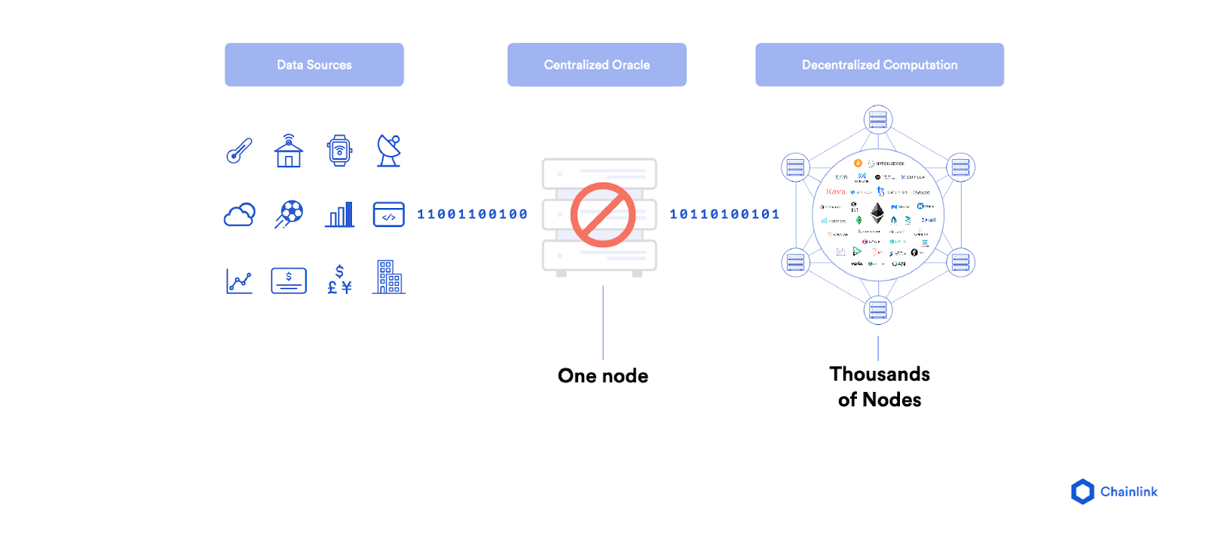A centralized oracle introduces a single point of failure in the delivery of data to the blockchain.

**Solution: The Chainlink Decentralized Oracle Network**

Chainlink, a decentralized oracle network, was developed to allow smart contracts to automate the transfer of data between blockchains and outside systems in a highly secure and reliable manner. It uses a similar model to a blockchain in that there is a decentralized network of independent entities (oracles) that collectively retrieve data from multiple sources, aggregate it, and deliver a validated, single data point to the smart contract to trigger its execution, removing any centralized point of failure.

For example, Chainlink provides the USD price of Ethereum’s native cryptocurrency ETH to blockchains via the [ETH/USD Price Feed](https://feeds.chain.link/eth-usd), which uses numerous independent oracle nodes and data sources to source and deliver the price data (pictured below). The ETH/USD price oracle can then be used by a blockchain application to get the current price of ETH when being used as collateral to obtain a loan or to settle a prediction made about the future ETH price.

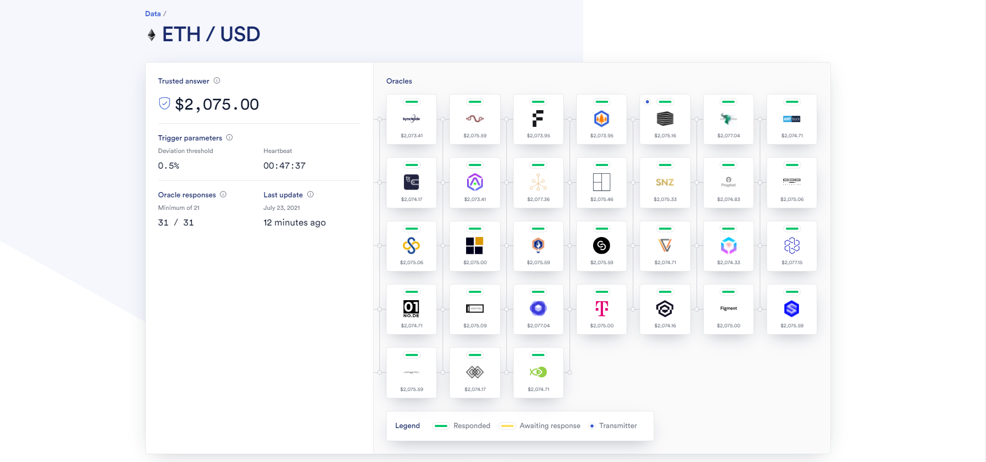The ETH/USD Chainlink Price Feed aggregates price data from numerous independent oracle node operators.

**Chainlink : Understanding in better way**

*Chainlink is a decentralized oracle network that provides real-world data to smart contracts on the blockchain. Smart contracts are pre-specified agreements on the blockchain that evaluate information and automatically execute when certain conditions are met. LINK tokens are the digital asset token used to pay for services on the network.*

**Understanding Chainlink Smart Contracts**

To understand the benefits of [Chainlink](https://www.gemini.com/cryptopedia/glossary" \l "chainlink-link) and how it functions, you need to understand some fundamental, interconnected concepts. Let’s start with [smart contracts](https://www.gemini.com/cryptopedia/glossary" \l "smart-contract).

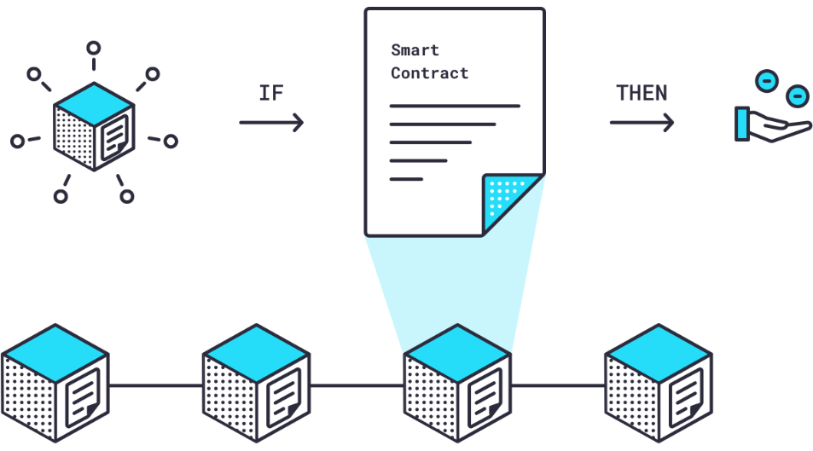Smart contracts are pre-specified agreements on the blockchain that evaluate information and automatically execute when certain conditions are met. Crowdfunding is a good example: if a certain amount of [ether (ETH)](https://www.gemini.com/cryptopedia/ethereum-blockchain-eth-fees-ether-transaction) is deposited into a smart contract by a certain date, then payment will be released to the fundraiser — if it is not, then payment will be returned to donors. Because smart contracts exist on a blockchain, they are [immutable](https://www.gemini.com/cryptopedia/glossary" \l "immutability) (can’t be changed) and verifiable (everyone can see them), guaranteeing a high level of trust among parties that they accurately reflect the stated parameters of the agreement and will execute if, and only if, those parameters are met.

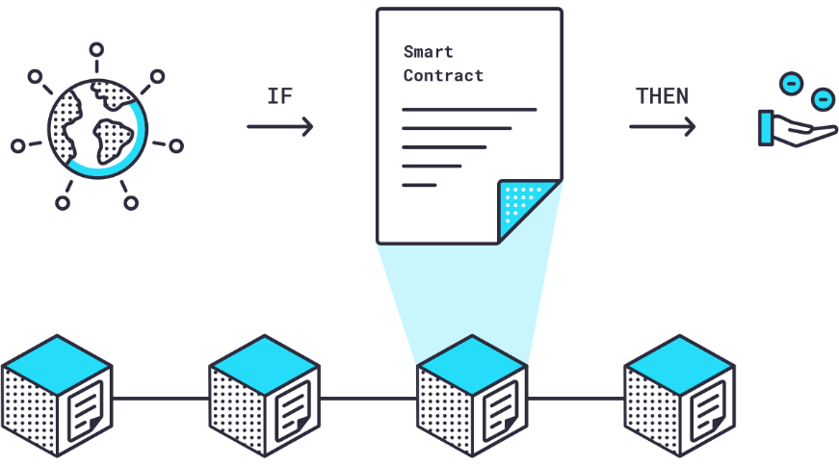For smart contracts to craft agreements beyond those that pertain to data found on the blockchain, they require [off-chain](https://www.gemini.com/cryptopedia/glossary" \l "off-chain)*data* in an [on-chain](https://www.gemini.com/cryptopedia/glossary" \l "on-chain)*format*. The difficulty in connecting outside information sources to blockchain smart contracts in a language that they both understand is one of the main limitations in how widely smart contracts can be used.

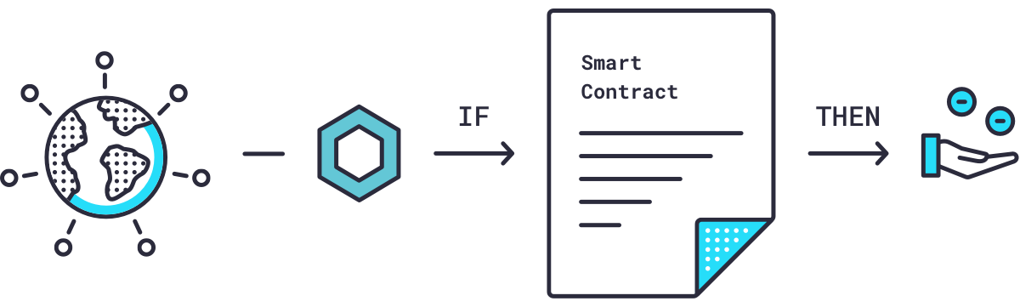

**Chainlink Oracles Bridge the On- and Off-Chain Chasm**

This is where [oracles](https://www.gemini.com/cryptopedia/glossary" \l "oracle) come into play. An oracle is software known as ‘[middleware](https://www.gemini.com/cryptopedia/glossary" \l "middleware)’ that acts as an intermediary, translating data from the real world to smart contracts on the blockchain and back again.

However, a single [centralized](https://www.gemini.com/cryptopedia/glossary" \l "centralization) oracle creates the very problem a [decentralized](https://www.gemini.com/cryptopedia/glossary" \l "decentralized-decentralization), blockchain-secured smart contract aims to solve — a central point of weakness. If the oracle is faulty or compromised, how would you know if your data is accurate? What good is a secure, trustworthy smart contract on the blockchain if the data that feeds it is in question?

So, let’s do a quick recap on smart contracts and oracles:

1. Smart contracts are immutable and verifiable contracts that automatically execute in an IF/THEN framework when conditions are met.
2. The data that defines these conditions has traditionally come from the blockchain.
3. Recently, oracles have been introduced into the crypto ecosystem to bring off-chain data to on-chain smart contracts.
4. But, centralized oracles diminish the benefits of on-blockchain smart contracts because they may be untrustworthy or faulty.

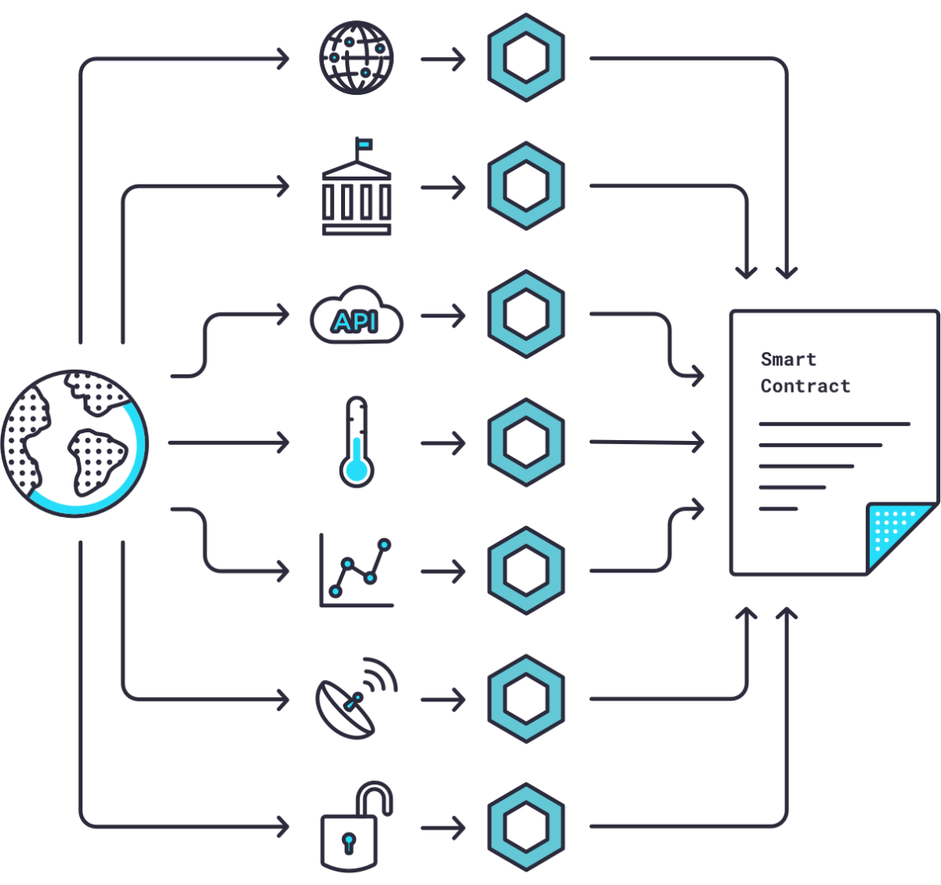

Chainlink is a [decentralized network](https://www.gemini.com/cryptopedia/glossary" \l "decentralized-network) of nodes that provide data and information from off-blockchain sources to on-blockchain smart contracts via oracles.

This process, along with extra secure hardware, eliminates the reliability issues that might occur if using only a single centralized source.

s**How Chainlink Nodes Reliably Validate Data**

Chainlink nodes then take the Requesting Contract’s request for data and use “Chainlink Core” software to translate that request from on-blockchain programming language to an off-blockchain programming language a real-world data source can understand. This newly translated version of the request is then routed to an external [application programming interface (API)](https://www.gemini.com/cryptopedia/glossary" \l "application-programming-interface-api) that collects data from that source. Once the data has been collected, it’s translated back into on-blockchain language through Chainlink Core and sent back to the Chainlink Aggregating Contract.

Here’s where things get really interesting. The Chainlink Aggregating Contract can validate data from a *single* source and from *multiple* sources — and it can reconcile data from multiple sources.

So, if five nodes deliver one answer from a weather sensor and two other nodes deliver a different answer, the Chainlink Aggregating Contract will know that those two nodes are faulty (or dishonest) and discard their answers. In this manner, Chainlink nodes can validate data from a single source.



The Chainlink Aggregating Contract can repeat this validation process for multiple sources, then reconcile all validated data by averaging it into a single piece of data. Under certain circumstances, not all answers can be averaged but for simplicity’s sake we won’t go further into depth here.

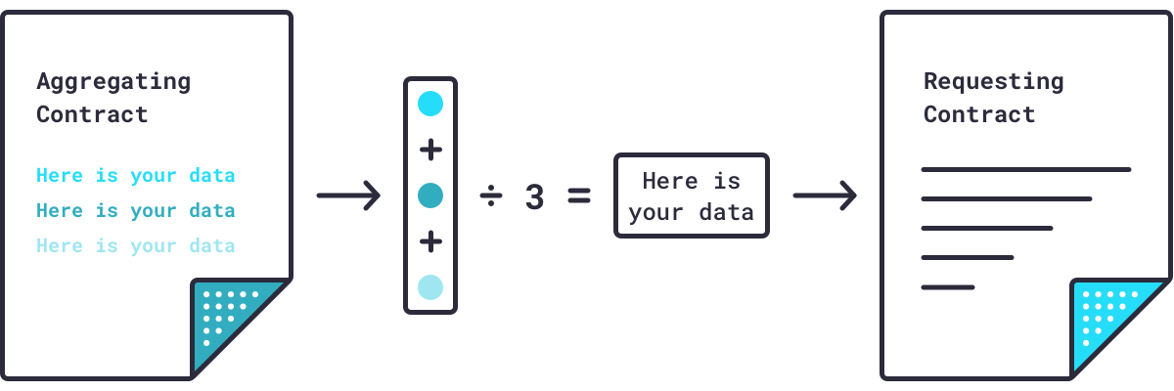

The data source aside, Chainlink has created a way to reliably, and efficiently, provide accurate data to smart contracts on smart-contract enabled blockchains.

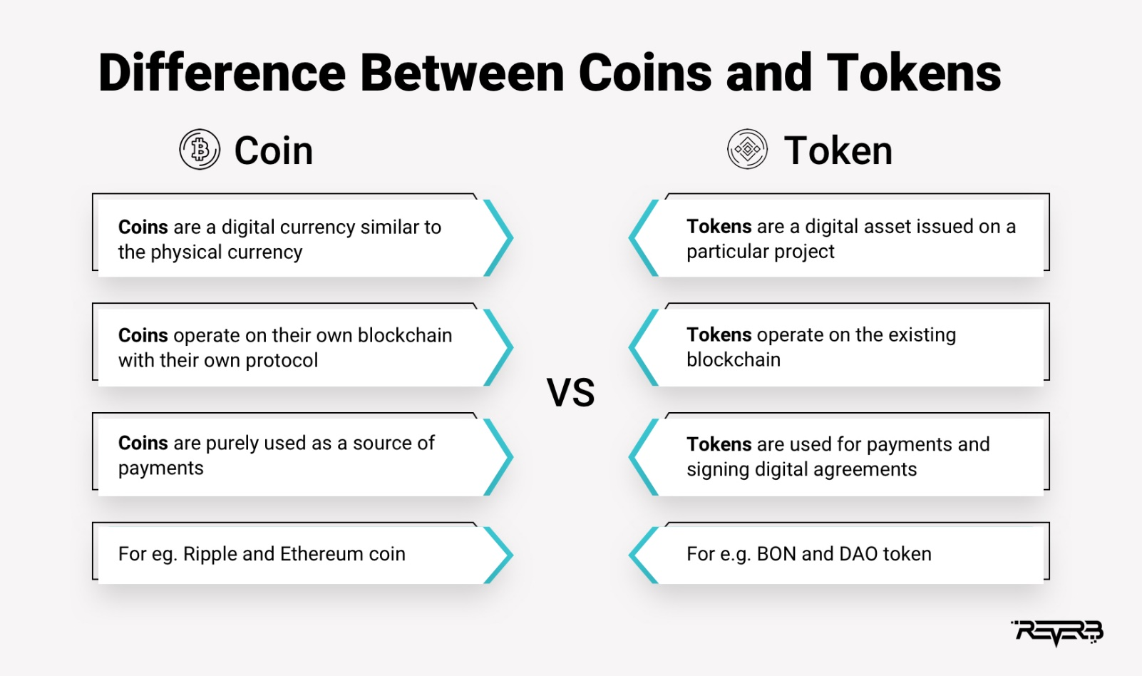

**What is a Token?**

Tokens can represent virtually anything in Ethereum:

* reputation points in an online platform
* skills of a character in a game
* lottery tickets
* financial assets like a share in a company
* a fiat currency like USD
* an ounce of gold
* and more...

Such a powerful feature of Ethereum must be handled by a robust standard, right? That's exactly where the ERC-20 plays its role! This standard allows developers to build token applications that are interoperable with other products and services.

**What are ERC Standards?**

An ‘Ethereum Request for Comments’ (ERC) is a document that programmers use to write smart contracts on Ethereum Blockchain. They describe rules in these documents that Ethereum-based tokens must comply with.

The Ethereum community uses a process called the ‘Ethereum Improvement Proposal’ to review these documents. They comment on it and as a result of that, the developer that created the document may revise it.

The Ethereum community accepts some of these documents after working through the EIP process, finalizes it, and then developers implement it. This is how the document becomes an ERC. In other words, ERCs originate as EIPs and could address different areas, for e.g., tokens, registration name, etc.

While there are several Ethereum standards. These ERC Ethereum standards are the most well-known and popular –

* ERC - 20
* ERC - 721
* ERC - 1155
* ERC - 777

**ERC 20 standard – The Most Popular Token Standard**

[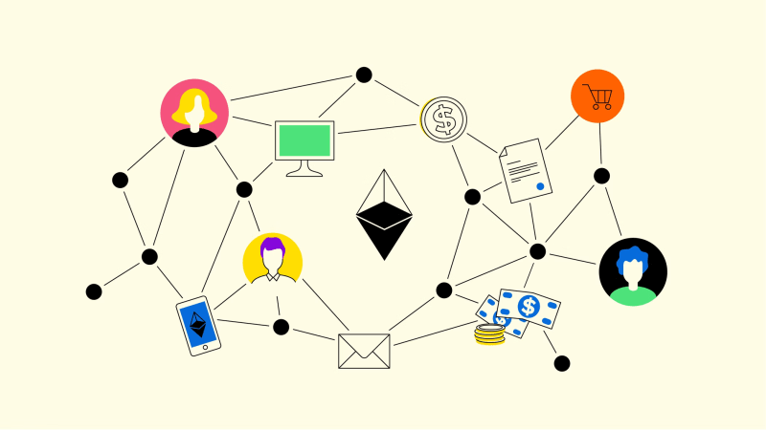](https://res.cloudinary.com/practicaldev/image/fetch/s--4kWFg3sS--/c_limit%2Cf_auto%2Cfl_progressive%2Cq_auto%2Cw_800/https:/dev-to-uploads.s3.amazonaws.com/uploads/articles/cnmwm4o8b5jnil2sow22.png)

The ERC-20 introduces a standard for Fungible Tokens, in other words, they have a property that makes each Token be exactly the same (in type and value) as another Token. For example, an ERC-20 Token acts just like the ETH, meaning that 1 Token is and will always be equal to all the other Tokens.

The ERC-20 token standard allows developers to create their own tokens on the Ethereum network. It has provided an easier route for companies to develop blockchain products instead of building their own cryptocurrency.

Some tokens, like Uniswap's UNI token, are set to remain ERC-20 tokens; other cryptocurrencies, such as Binance Coin, have since jumped over to their own blockchains.

These tokens are:

* 💻 Fungible - The code of each individual token is the same as any other, though transaction histories can be used to identify and separate out the tokens involved.
* 🛫 Transferable - They can be sent from one address to another.
* ⛏️ Fixed supply - A fixed number of tokens must be created so that developers cannot issue more tokens and raise the supply.

Since the ERC-20 token standard was finalized, over 500,000 tokens compatible with ERC-20 have been issued. Some of the leading ERC-20 tokens include:

* 🦄 Uniswap (UNI) - A decentralized exchange (DEX) that enables users to swap tokens peer-to-peer, without relying on a centralized intermediary.
* 👾 Decentraland (MANA) - The token underpinning metaverse platform Decentraland, MANA is burned in order to acquire non-fungible LAND tokens representing plots of virtual land.
* 🦍 ApeCoin (APE) - The utility and governance token for the Bored Ape Yacht Club ecosystem, based on the popular PFP (profile picture) NFT collection.

**Disadvantages of ERC-20 tokens?**

* ⚠️ Low throughput - The Ethereum network has been clogged up when dapps have experienced high demand, such as CryptoKitties (which has since moved to its own Flow blockchain). When this happens, the network slows down and transactions become more expensive.
* 🐢 Slow transactions - The block time is around 14 seconds, so transactions can take up to a minute to process. This may be adequate for some uses or too slow for others.
* ⏲️ ETH - When transactions are made involving ERC-20 tokens, a second cryptocurrency is needed to pay for the transaction fees. This can add both time and cost, as it can result in dust on different platforms.

**ERC 721 – The Standard for Non Fungible Tokens**

[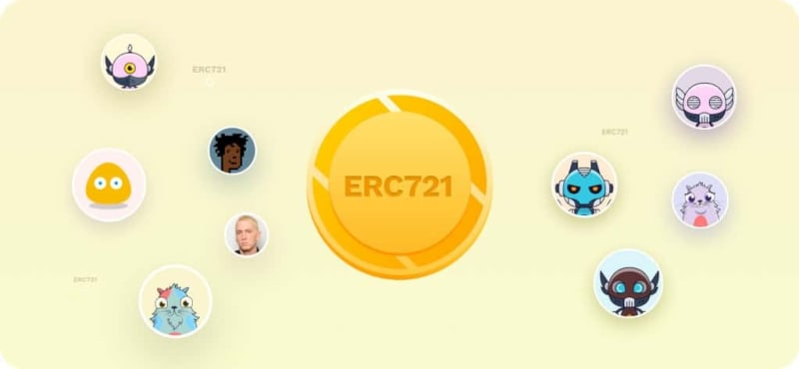](https://res.cloudinary.com/practicaldev/image/fetch/s---IX_OJGm--/c_limit%2Cf_auto%2Cfl_progressive%2Cq_auto%2Cw_800/https:/dev-to-uploads.s3.amazonaws.com/uploads/articles/gx0k6l1qs8wjptjfi0qt.jpg)ERC-721 is a token standard on Ethereum for non-fungible tokens (NFTs). Fungible means interchangeable and replaceable; Bitcoin is fungible because any Bitcoin can replace any other Bitcoin. Each NFT, on the other hand, is completely unique. One NFT cannot replace another.

The main characteristic of ERC-721 tokens is that each one is unique. When an ERC-721 token is created, there is one and only one of those tokens in existence. These tokens, as NFTs, have spread the idea and application of unique assets on Ethereum.

**What can you do with ERC-721 NFTs?**

Today, the most common use case for ERC-721 NFTs is for digital art. Users buy these NFTs for a number of reasons, including supporting artists, investing long-term in hopes that the price will go up, quickly flipping/trading NFTs for a profit, or simply because they like the artwork.

However, use cases for NFTs extend beyond digital art.

NFTs are commonly used in blockchain-based games, such as [Gods Unchained](https://godsunchained.com/), to represent unique assets within the game. The online collectible card game uses NFTs to represent digital cards, which can then be traded with other players or used in battles. Some blockchain-based games even let you move your items over to different games. This is the beginning of the Metaverse, a persistent virtual environment in which NFTs represent digital objects that can be moved between different platforms.

Music NFTs are also becoming increasingly popular. Platforms such as [Audius](https://audius.co/) make it easy for artists to mint their work as ERC-721 tokens.

**ERC-1155 - Ethereum’s Flexible Token Standard**

[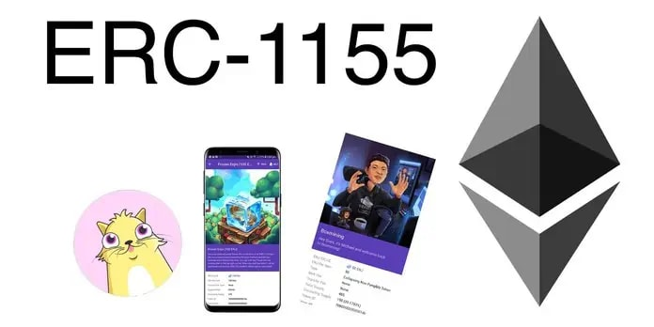](https://res.cloudinary.com/practicaldev/image/fetch/s--2qNE4wsC--/c_limit%2Cf_auto%2Cfl_progressive%2Cq_auto%2Cw_800/https:/dev-to-uploads.s3.amazonaws.com/uploads/articles/dy0k1tsh30woqyu723zz.png)Prior to ERC-1155, the two predominant token standards were ERC-20 for fungible tokens and ERC-721 for non-fungible tokens. They could not (and cannot) be wrapped into the same smart contract. This limitation meant that if someone wanted to transfer, say, USDC (ERC-20) and a CryptoKitties NFT (ERC-721), they would need to execute multiple transactions, which was inefficient and expensive.

ERC-1155 solves for this by combining the two token standards. ERC-1155 is a token standard that enables the efficient transfer of fungible and non-fungible tokens in a single transaction.

**How does ERC-1155 work?**

The initial motivation behind ERC-1155 was to address challenges faced by blockchain game developers and players.

Massively multiplayer online games (MMOs) contain tens of thousands of items—armor, weapons, shields, skins, coins, badges, castles, etc—that players can collect and trade with one another. Some items like coins are fungible while others like a sword are non-fungible. On the blockchain, each one of these items is a token.

**Prior to ERC-1155, each item required its own smart contract. In a game with 100,000 items that means 100,000 smart contracts!**

With an ERC-1155 token, multiple items can be stored in a single smart contract and any number of items can be sent in a single transaction to one or more recipients. This means if you wanted to send a sword to one friend, a shield to another, and 100 gold coins to both, you could do so in only one transaction.

**What's so special about ERC-1155?**

As well as allowing for the transfer of multiple token types at once, and the attendant gains in efficiency and lower transaction costs, ERC-1155 has a number of other special characteristics:

* It supports an infinite number of tokens, in contrast with ERC-20 and ERC-721, which require a new smart contract for each type of token.
* It supports not only fungible and non-fungible tokens, but also semi-fungible tokens. Semi-fungible tokens are like general admission concert tickets. They are interchangeable and can be sold for money before the show (fungible). But after the show they lose their pre-show value and become collectibles (non-fungible).
* It has a safe transfer function that allows tokens to be reclaimed if they are sent to the wrong address, unlike ERC-20 and ERC-1155
* It removes the need to "approve" individual token contracts separately, which means signing fewer transactions

**Who's using ERC-1155?**

* 🎮 Enjin - Enjin offers a number of blockchain products, many of which implement ERC-1155.
* 🕹️ Horizon - Horizon is a blockchain games company whose [Skyweaver](https://horizon.io/" \l "skyweaver) game uses ERC-1155.
* 🖼️ OpenSea - The NFT marketplace's ERC-1155 implementation allows multiple creators per smart contract but only one creator is able to mint more copies.
* 🎈 OpenZeppelin - OpenZeppelin's blockchain security products leverage the ERC-1155 standard.

**ERC 777 – Reduces Friction in Crypto Transactions**

ERC-777 is a token standard for fungible tokens introduced on the Ethereum network that is fully compatible with existing decentralized exchanges.

It facilitates complicated token trade interactions and assists the removal of ambiguity around decimals, minting, and burning. It utilizes a distinctively effective feature called a hook.

A hook is simply a function in a contract that is called when tokens are sent to it, meaning accounts and contracts can react to receiving tokens.

When tokens are delivered to a computer-based analytical contract, it activates a hook mechanism that streamlines how accounts and contracts communicate when receiving tokens. Furthermore, ERC-777 tokens are significantly less likely to get stuck in a contract, which is traditionally seen as a problem with ERC-20 tokens.

Hooks are programmed into the standard. If you transfer ETH to a smart contract, it will be alerted about the incoming ETH through the hooks, a feature that ERC20 tokens don’t have. The following are the benefits of this standard:

* The ERC777 standard is backwards compatible with ERC20, meaning you can interact with these tokens as if they were ERC20, using the standard functions
* ERC-777 enables anyone to add extra functionality to tokens, such as a mixer contract, for greater transaction confidentiality, or an emergency recovery feature to help you if you lose your private keys.

**What Is a Crypto Wallet?**

Cryptocurrency wallets store users’ public and private keys, while providing an easy-to-use interface to manage crypto balances. They also support cryptocurrency transfers through the [blockchain](https://crypto.com/university/what-is-blockchain-consensus?utm_source=crypto.com+university&utm_medium=referral&utm_campaign=what+is+a+crypto+wallet&utm_content=blockchain). Some wallets even allow users to perform certain actions with their crypto assets, such as buying and selling or interacting with [decentralised applications (dapps)](https://crypto.com/university/decentralised-finance-defi-intro?utm_source=crypto.com+university&utm_medium=referral&utm_campaign=what+is+a+crypto+wallet&utm_content=decentralised+applications+(dapps)).

It is important to remember that cryptocurrency transactions do not represent a ‘sending’ of crypto tokens from a person’s mobile phone to someone else’s mobile phone. When sending tokens, a user’s private key signs the transaction and broadcasts it to the blockchain network. The network then includes the transaction to reflect the updated balance in both the sender’s and recipient’s address.

So, the term ‘wallet’ is somewhat of a misnomer, as crypto wallets don’t actually store [cryptocurrency](https://coinchapter.com/news/) in the same way physical wallets hold cash. Instead, they read the public ledger to show the balances in a user’s addresses, as well as hold the private keys that enable the user to make transactions.

**Not Sure What a Public or Private Key Is?**

A key is a long string of random, unpredictable characters. While a **public key** is like a bank account number and can be shared widely, the **private key** is like a bank account password or PIN and should be kept secret. In public-key cryptography, every public key is paired with one corresponding private key. Together, they are used to encrypt and decrypt data.

**Why a Crypto Wallet Is Needed**

A user’s cryptocurrency is only as safe as the method they use to store it. While crypto can technically be stored directly on an exchange, it is not advisable to do so unless in small amounts or with the intention of trading frequently.

For larger amounts, it’s recommended that a user withdraws the majority to a crypto wallet, whether that be a hot wallet or a cold one. This way, they retain ownership of their private keys and have full power and control over their own finances.

**How Do Cryptocurrency Wallets Work?**

As mentioned earlier, a wallet doesn’t technically hold a user’s coins. Instead, it holds the *key* to their coins, which are stored on public blockchain networks.

In order to perform various transactions, a user needs to verify their address via a private key that comes in a set of specific codes. The speed and security often depend on the kind of wallet a user has.

**Different Types of Crypto Wallets**

There are two main types of crypto wallets: software-based hot wallets and physical cold wallets. Read on to learn about the different types of cryptocurrency wallets, and which may be a best fit.

**Hot and Cold Wallets — What’s the Difference?**

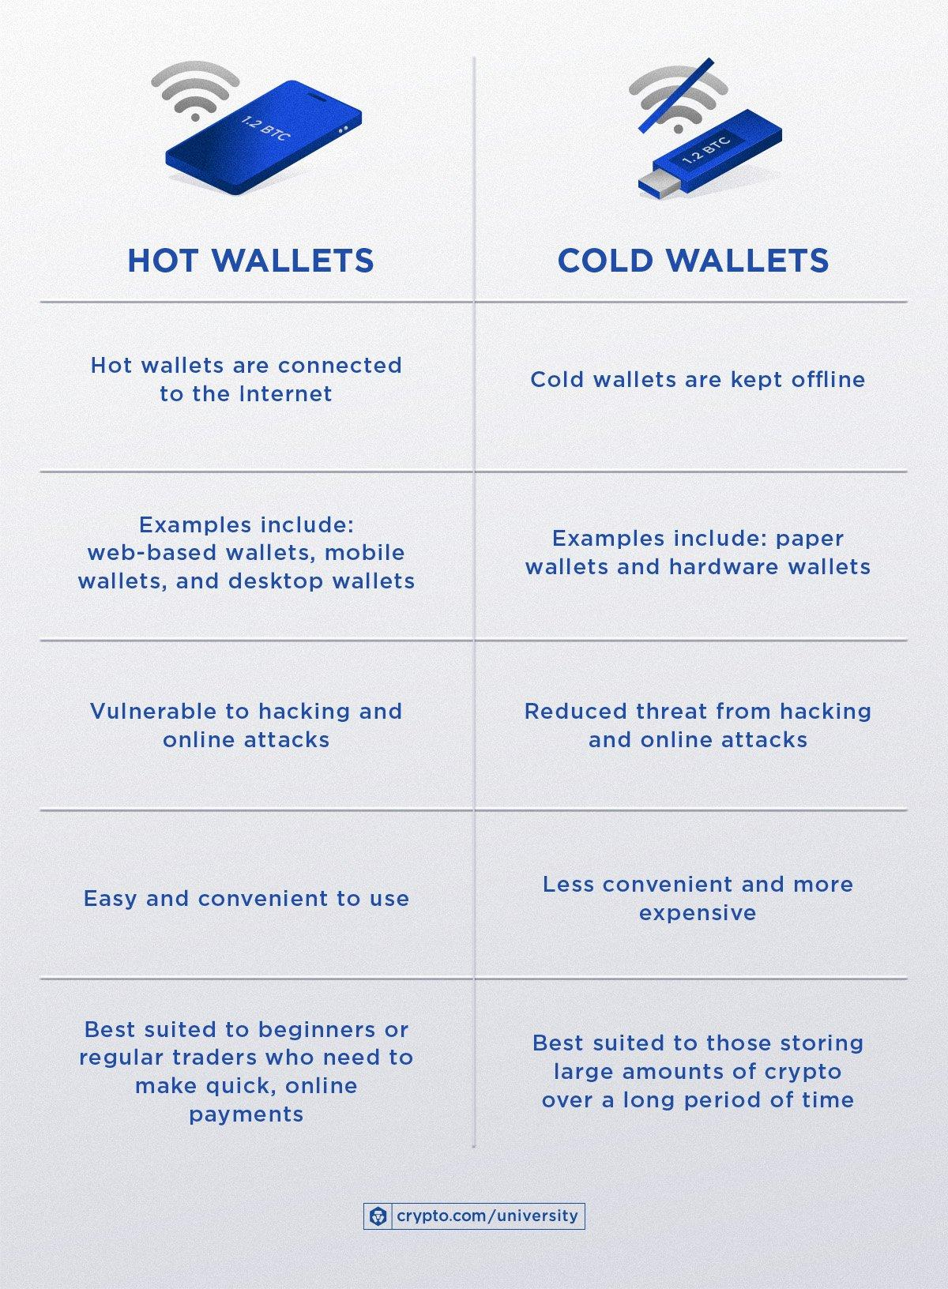

**Hot Wallets**

The main difference between hot and cold wallets is whether they are connected to the Internet. **Hot wallets are connected to the Internet, while cold wallets are kept offline.** This means that funds stored in hot wallets are more accessible and, therefore, easier for hackers to gain access to.

**Examples of hot wallets include:**

* Web-based wallets
* Mobile wallets
* Desktop wallets

In hot wallets, private keys are stored and encrypted on the app itself, which is kept online. Using a hot wallet can be risky since computer networks have hidden vulnerabilities that can be targeted by hackers or malware programmes to break into the system. Keeping large amounts of cryptocurrency in a hot wallet is a fundamentally poor security practice, but the risks can be mitigated by using a hot wallet with stronger encryption, or by using devices that store private keys in a secure enclave.

There are different reasons why a market participant might want their cryptocurrency holdings to be either connected to or disconnected from the Internet. Because of this, it’s not uncommon for cryptocurrency holders to have multiple cryptocurrency wallets, including both hot and cold ones.

**Cold Wallets**

As introduced at the beginning of this section, a cold wallet is entirely offline. While not as convenient as hot wallets, cold wallets are far more secure. An example of a physical medium used for cold storage is a piece of paper or an engraved piece of metal.

**Examples of cold wallets include:**

* Paper wallets
* Hardware wallets

**What Is a Paper Wallet?**

A paper wallet is a physical location where the private and public keys are written down or printed. In many ways, this is safer than keeping funds in a hot wallet, since remote hackers have no way of accessing these keys, which are kept safe from phishing attacks. On the other hand, it opens up the potential risk of the piece of paper getting destroyed or lost, which may result in irrecoverable funds.

**What Is a Hardware Wallet?**

A [hardware wallet](https://crypto.com/university/what-is-a-hardware-wallet?utm_source=crypto.com+university&utm_medium=referral&utm_campaign=what+is+a+crypto+wallet&utm_content=hardware+wallet) is an external accessory (usually a USB or Bluetooth device) that stores a user’s keys; a user can only sign a transaction by pushing a physical button on the device, which malicious actors cannot control.

The best practice to store cryptocurrency assets that do not require instant access is offline in a cold wallet. However, users should note this also means that **securing their assets is entirely their own responsibility** **—** it is up to them to ensure they don’t lose it, or have it stolen.

*Tip: For increased security, separate the public and private keys, keep them offline, and store the physical wallet in a safe deposit box.*

**Hot Wallets vs Cold Wallets: Which Are Better?**

While both methods of storage have benefits and drawbacks, the option depends on a user’s preference. For example:

* For day-to-day trading, accessibility is of paramount importance, meaning that a hot wallet may be worth researching.
* However, for those considering storing a huge amount of crypto assets and who value security over convenience, then consider researching a cold wallet.

**Solidity**

Solidity is an object-oriented programming language created specifically by Ethereum Network team for constructing smart contracts on various blockchain platforms, most notably, Ethereum.

* It’s used to create smart contracts that implements business logic and generate a chain of transaction records in the blockchain system.
* It acts as a tool for creating machine-level code and compiling it on the Ethereum Vitural Machine (EVM).

